

A Taste of Ghana 

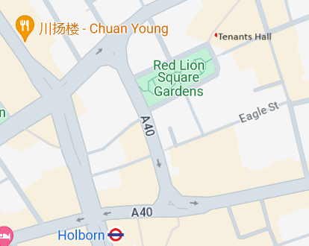Come and join us at our Annual Summer Party!

Saturday 27 July 2024 16.30 – 19.30

The Garden, The Tenants’ Hall

Underneath Tresham

Lambs Conduit Passage

London WC1R 4RE

(nearest Tube station: Holborn)

Every summer, Ashantis living in London cook us a Ghanaian meal to thank us for the work we’ve done for them and for Ashanti over the past year.

Please come and join us in eating it. We will also have a stall selling gifts and souvenirs made in our dressmaking school in Ghana, and a raffle. And it’s a lovely place for children to play. Everyone’s welcome.

Tickets £20 (concessions £15) Children are free. Pay at the door by cash or credit card or book through Eventbrite at £16

https://www.eventbrite.com/e/a-taste-of-ghana-tickets-938773044447

21 Downing Court Reg. Charity No. 1133517

Grenville Street Company No. 7113261

London WC1N 1LX www.ashantidevelopment.org

Tel: 0207 837 3172/07713 743 398 www.twitter.com/ashanticharity