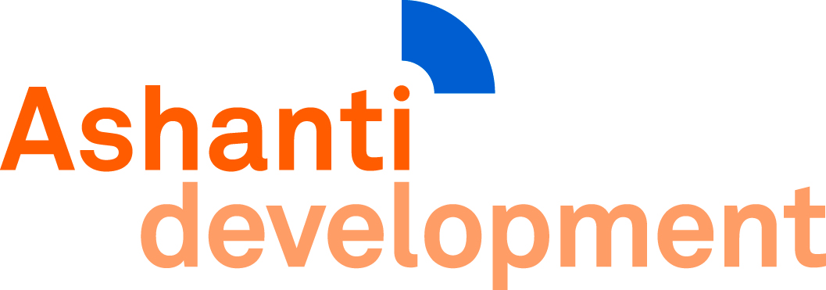

ASHANTI DEVELOPMENT
(A company limited by guarantee)

Directors’ Report and Financial Statements
for the Year Ended 31 December 2018

Registered charity numbers: 1133517
Company number: 07113261 registered in England and Wales

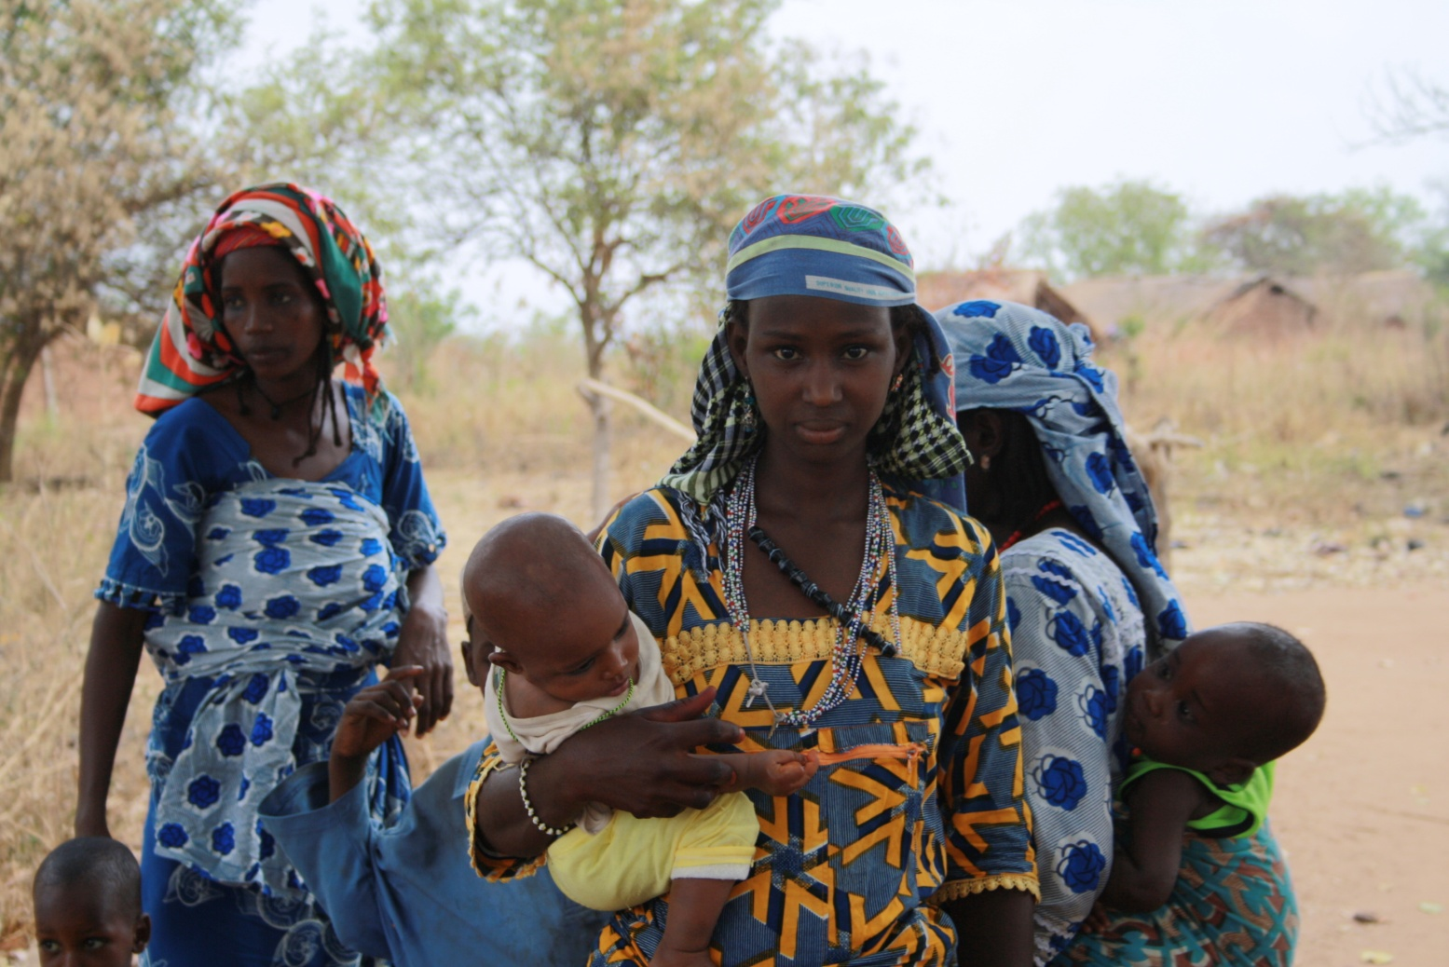

Contents
General Information 2
Directors' Report 3
Statement of Financial Activities 11
Balance Sheet 12
Notes to the Financial Statements 13

General Information
Ashanti Development is a charitable company limited by guarantee, incorporated on 29 December 2009. The company has no share capital.

Registered Office:
21 Downing Court
Grenville Street
London WC1N 1LX

Telephone: +44 (0)207 837 3172 +44 (0)7713 743 398
Website: ashantidevelopment.org
E-mail: info@ashanti-development.org.uk

The Directors shown below have held office during the whole period from 1st January 2018
to 31st December 2018:
ALBERT, Antwi
BOADU, Martha Appiah
BOOTH, Helen Louise
DAVID, Penny
HARTLEY-SHARPE, Christopher James
KEEP, Judith-Anne Esme
REES, David Charles, Professor
SHAH, Antony Arjum
WILLIAMSON, Dawn

Directors' Report
Mission Statement
To relieve poverty and promote health and development in and around the Ashanti Region of Ghana by means including the provision of safe and accessible water.
Key Objectives
1. To provide all communities with clean water, sanitation, and health and hygiene education, and to strengthen village institutions to the point where they are able to maintain these improvements.
2. To improve health, particularly eye health, and increase longevity.
3. To boost educational standards, including literacy, numeracy, computer and agricultural skills.
4. To create an environment within which each individual can earn a living wage.
Cross Objectives
5. To raise sufficient funds for Ashanti Development’s work.
6. To ensure that activities are based on proper knowledge and information, take account of risk and are carried out regardless of colour, creed, race or sex.
7. To ensure that Ashanti Development works efficiently and complies with legal and financial requirements.
Our partners include:
- Ashanti Development (Ghana), an independently registered Ghanaian NGO
- Ashanti Development (Italia), an independently registered Italian NGO
- UK based donors and volunteers
- Ashanti communities, and their representative organisations at all levels
Board of Directors
All Directors continued to serve during 2018, and three retired by rotation and were re-elected in July. Tony Shah, a recently retired wealth manager, joined the Board in March.
Between meetings, Directors received updates on the charity’s financial situation, which they discussed in detail at their regular meetings, three of which took place in 2018. They also responded to changes to statutory and other requirements, for example, agreeing a privacy statement following enactment of Data Protection legislation, updating the Safeguarding Code and considering Risks and Reserves. Three issues of Ashanti News were produced.
Directors also participated in writing and designing a new website, and approving a new, volunteer-sponsored leaflet. They obtained grants from Hands International and the Muslim Community and Education Centre for sponsoring over thirty cataract operations and from the Wimbledon Foundation for Centre Court tickets to auction.
Two of the Directors funded a successful operation on a small girl to mend a hole in her heart.
Directors also received regular reports from Ghana, on subjects including work in progress, cataract surgery and microcredit; and reports from returning volunteers. Talks were also given to Bedford Academy and Crofton Junior School.
No remunerations were received by directors within reporting year, all directors act on a voluntary basis.
Ghana Staff
Staff in Ashanti continued to be headed by Director Nicholas Aboagye, who took overall responsibility for staff and their work. He was supported by Microcredit Manager, Mavis Bobie, Optometrist Agnes Oppong, and seventeen other members of staff.
General
Ashanti Development’s home village, Gyetiase, was the first to which we attempted to provide water and sanitation, only succeeding with the water after many years. Since then, we have worked outward in a circle, and have completed most villages within a day’s journey. The exceptions are mainly villages located on granite, where the 16 foot latrine pit cannot be dug. For this we can find no remedy without spending large sums of money.
Our intentions until recently were therefore to set up a new centre some way north of the northern edge of the circle, since conditions in the north are worse than those in Ashanti. We planned perhaps to build a school and use it for volunteer accommodation until work within the new circle was complete, when we would again move north, leaving a school building behind us. However in the last few years a steady and growing stream of immigrants has arrived in our area. They are people previously living in Northern Ghana or Burkina Faso, who have come south because climate change and increased temperatures have made it extremely difficult for them to maintain life in their home villages.
The immigrants are from many different tribes, including the Dagati, Kokombas, Dagomba, Mamprusis, Kusasis, Grusi, Mossi, Frafra, Fulani and Kusasis, some of whom are aggressive. They rent land from a local chief and either farm it or, if they are nomadic, allow their cattle to graze on it. Some burn the scrub to allow their cattle to feed on young grass that springs up after fires, and they sometimes burn down villages at the same time.
These immigrants are also the poorest of the poor, have very few possessions and lack everything that could make their lives easier. We aim to provide them above all else with clean water, sanitation and training in health and hygiene, simultaneously strengthening their institutions so they can maintain the improvements independently.
The role of many of the volunteers to Ashanti is also changing, not least because of their strong desire for more direct contact with local people. We still have volunteers who carry out professional work, like teaching or medicine, but many others help by examining and reporting back on various projects, or by interviewing local people about their experience. We cannot claim this is an ideal way to assess projects, but our projects are of many sorts, and we cannot find appropriate, impartial third parties to cover them all. In these circumstances, our volunteers’ work is valuable, and they often identify weaknesses we had not noticed. One volunteer reported that the state of latrines in our home village was particularly bad. After enquiries, we inaugurated a competition for Best Latrine, with small cash prizes for the three winners. It remains to be seen if the improvement will be permanent, but at the very least this arrangement provides interesting case studies for our own or donors’ websites.
Water and Sanitation
By the end of 2018, Ashanti Development had provided for 2,039 latrines to be built, accommodating 24,500 people. The principal villages worked on during 2018 were Aframano, Timber Nkwanta II, Bobin, Ebuoso and Hwiediem, with a total population of just over 3,000. All the villages are in Mampong Municipal District.
One of Ashanti Development’s three founders was David Williamson, a former consultant to WaterAid, who insisted we follow WaterAid practice. We therefore treat the provision of clean water, sanitation and hygiene training as of equal importance. Building household latrines usually takes several months, and during this time we also train the villagers in health and hygiene.
The provision of clean water in this part of Ashanti is complicated, because of variations in the geological structure. In recent years, the siting of all boreholes has been based on geological information obtained for us by our volunteer hydrogeologists and geophysics, and none has failed to strike water. We also organised an inspection of all boreholes we had drilled in the past, and all were in good working order.
Healthcare
At the urgent request of volunteer Ruth Simpson, who once worked as a nurse at Mampong Maternity Hospital, Ashanti Development agreed to finance the renovation and re-equipment of some of the wards. We decided to look for sponsors to finance a room as a time, but only on condition that the Hospital undertook to maintain the improvements to a high standard; accepted that Ashanti Development would carry out the work on their behalf; and promised to allow us access to check the state of the wards at any time. The Hospital readily agreed this.
Shortly afterwards, we were approached by Sekyere Central District officers, who asked us to finance a maternity ward in their District, and told us they intended to ask other charities to finance other wards until eventually they had a hospital. We took advice on both these initiatives from our medical volunteers, who visited in November. They were uncertain about this last, given that Mampong Maternity Hospital is only a few kilometres away. This question is still unresolved.
Our medical volunteers also checked arrangements for baby-weighing and were pleased to note that all under-weight babies were already being given Weanimix (see below), an infant food supplement.
They also visited a new immigrant village called Onyameanie, or Eye of God, where unusual health problems had been reported. They found that the surrounding area was swampy, which accounted for the high incidence of malaria, and that the village was drinking stagnant water, had no form of sanitation and no understanding of hygiene. The medics also found a significant number of children had a contagious tropical disease called ‘Yaws,’ for which they sourced suitable medication.
Our medical volunteers also donated a defibrillator for use in any part of the hospital in an emergency. They organised screening programmes for hepatitis B, diabetes, blood pressure, TB and Aids and because of the high detection rates plan to support further screening in future. They noticed that there was a good uptake of condoms, particularly amongst men and teenage boys and arranged that these will in future be bought and distributed via village health workers.
Weanimix
Our staff now aim to time their visits to villages to coincide with those of the District Nurse. He or she records details of underweight infants but does nothing to rectify the problem. Our staff therefore add the babies concerned to their list of babies receiving Weanimix – a mixture of ground corn, peanuts and maize – which results in the babies putting on weight rapidly.
Worm Project
In early 2018, a major fire destroyed the Ghana Government’s main chemical store and medication became hard to find. The Government therefore decided to limit treatment for worms to the most needy regions, which did not include our home Districts.
Luckily, one of our volunteers had by then already set up a fund to pay for worm tablets, since many of the immigrant villages were not included on the Districts books. It follows that her donations were very important in preserving the health of many local children.
Eye Health
A total of thirty-five (35) Small Incision Cataract Surgeries (SICs) was carried out in September. The sixteen male and sixteen female patients came from both neighbouring and distant villages and towns.
Twenty three of them experienced a subsequent improvement in their visual acuity; seven of them recorded the same visual acuity as their first post-operative visual tests showed; while the remaining patient recorded a reduced visual acuity. Probing further into the possible cause of his reduced vision, we found he lived alone and was not able to administer his post-operative drugs adequately.
Education
Our principal aim for 2018 was to consolidate and improve exam results for school leavers (the BECE West Africa leavers exam) which in 2018 dropped to 82 per cent from a high of 89 per cent in 2016.
At the outset, we agreed with District staff to focus on schools at risk of turning in low exam results, which involved identifying and working with headteachers, teachers and pupils in need of support. Circuit supervisors ensured that extra classes and revision for targetted pupils were set up, in some cases organising and running them themselves, as well as undertaking revision lesson planning with staff.
Where our volunteer teacher-trainer was unable to attend monitoring and training visits he was sent written reports, lesson plans, revision activities and photographs of the training taking place through the group’s WhatsApp.
Ashanti Development contributed to the costs of running a full mock exam for all District JHS 3, a gesture which was greatly appreciated by the District Director of Education. This is a huge undertaking and is still in the planning stage. If it goes well and staff supplement the mock with revision, it should have a positive impact on exam results.
Finally our teacher-trainer conducted research in two settler villages, Congo 3 and Oku, as part of his work for a Masters Degree. These two communities come from the northern regions of Ghana, which are considerably poorer than the rest of the country. They are remote and very poor, though other villages in the Afram Plains forest fringes are even poorer. They desperately need water, electricity, sanitation, teacher accommodation, medical care and social support systems.
School Twinning
In February volunteer Dawn Williamson visited several twinned schools in Ghana. Some had previously been sent equipment by their UK partners – for example laptops, desks and sports kit – or letters, photos and project work.
These were all being used and additional ideas were given to increase their effectiveness. Since then some teachers in the English schools have either retired or moved to other schools and, as stress in the classroom increases, communications have become harder.
Income Support
- Microcredit
Our microcredit project now covers some 1,500 women in 28 villages. The project has its own dedicated manager who reports regularly, by email and WhatsApp, to our microcredit volunteer in Scotland. Recently, she has begun to format her reports so that they can sent straight to donors, who appreciate regular updates.
We also offer loans on microcredit terms to villages which have proved themselves reliable. They use these for some communal benefit such as buying an extra water tank or a milling plant to convert cassava into its longlife form.
- Farm Support
The farm support scheme, created by our Ghana Director, has been an outstanding success, and Ashanti Development is keen to extend it as quickly as possible. Working with twenty farmers per village, it provides agricultural and marketing training and loans for farm inputs over a four year period, allowing the remaining farmers to come and watch the training. The model is easy to follow and good practice spreads quickly, as a result of which organisations including the British Overseas Trade Board have visited Ashanti to observe it in operation.
As a result of these project, many farmers harvests double, treble or grow even further. Farmers are sending their children to school for the first time and have built new homes or bought motor bicycles or small shops with the profit. We believe that other than in exceptional cases, the scheme has eradicated hunger from participating villages.
The scheme currently covers fourteen villages.
- Bee Keeping
Over the past six years, Ashanti Development volunteers have introduced bee keeping to sixteen villages, and trained local people to look after them. Bee keeping is a long-term venture; it takes time to develop skills, generate bee colonies, establish markets for honey and develop local trainers.
During 2018 bee keepers harvested some 700 lbs of honey at a value of around £2 per lb – a substantial amount of money in Ashanti and enough to fund equipment replacements or investments as well as making a good contribution to household income.
- Dressmaking
All fourteen students at the dressmaking school finished their three year apprenticeships at the end of the year, and all them passed their qualifying exams, set by the Ghana National Tailors and Dressmakers Association. Two girls from our home village, Gyetiase, won prizes for coming second and third.
The students’ next challenge will be to set themselves up in business. Most will raise a loan from their extended families to buy a sewing machine, and will repay as their businesses become profitable.
There is now a queue of girls competing to take their places.
Most of the girls at the school were single mothers, but since they started all have married or will soon do so. They will then move in with their husbands, not all of whom live locally. Because of this, there’s no danger that the local market for dressmaking will become saturated.
Museum
2018 saw the opening of our museum of local culture at Gyetiase, since when local people have been bringing in items to put on show. Most recently, for example, these have included a fetish priest’s robe, an old kerosene lantern and an ancient throne for a village queen. As a result, there’s an urgent need for more showcases.
Monitoring and Evaluation
We monitor all work for five years and less regularly thereafter. From time to time we evaluate specific projects.
Financial Review
Our funding came principally from the following courses
- grant-making trusts, foundations and other organisations
- our Develop A Village work. For this we profile some ten to fifteen villages, and estimate the cost of providing the materials and training to enable each household to build itself a household latrine. While the building is in process, we teach the community health and hygiene and strengthen its institutions to enable them to maintain the improvements. We encourage donors to visit Ashanti and make friends with the villages they’ve sponsored.
- individual donations
- fund-raising.
Reserves Policy
Ashanti Development holds a reserve of £9,698.32 in the UK to be used to cover salaries for our staff in Ghana for approximately one year.

Statement of Financial Activities
(incorporating an Income and Expenditure account)
for the year to 31 December 2018

 | 2018 |  |  | 2017
 | Restricted | Unrestricted | Total | Total
Incoming Resources
Donations | £158,501.79 | £48,842.94 | £207,344.73 | £186,154.45
Total Income | £158,501.79 | £48,842.94 | £207,344.73 | £186,154.45
Resources Expended
Project Work | £98,630.48 | £5,309.77 | £103,940.25 | £180,092.04
Operating costs (including salaries) in Ghana | £0.00 | £33,485.85 | £33,485.85 | £35,718.32
Bank or Other finance expenses | £0.00 | £0.00 | £0.00 | £0.00
Equipment purchase for Ghana | £0.00 | £0.00 | £0.00 | £0.00
Total resources expended | £98,630.48 | £38,795.62 | £137,426.10 | £215,810.36
Net income/expenditure (-) For the year | £59,871.31 | £10,047.32 | £69,918.63 | -£29,655.91
Transfers between funds | £0.00 | £0.00 | £0.00 | £0.00
Balance at 1 January b/f | £34,753.54 | £13,264.12 | £48,017.66 | £77,673.57
Closing reserves | £94,624.85 | £23,311.44 | £117,936.29 | £48,017.66

Notes:
All of the above results are derived from continuing activities. All gains and losses in the year are included above.

Balance Sheet
for the year to 31 December 2018

 | 2018 | 2017
Fixed Assets | - | -
Current Assets | £112,083.57 | £48,017.66
Cash at Bank and Hand | £90,526.84 | £35,805.88
Funds in Ghana | £21,556.73 | £12,211.78
Creditors | £0.00 | £0.00
Net Current Assets | £112,083.57 | £48,017.66
Funds | £112,083.57 | £48,017.66
Restricted | £94,624.85 | £34,753.54
Unrestricted | £17,458.72 | £13,264.12

For the year ended 31 December 2018 the company was entitled to exemption under section 477 of the Companies Act 2006 relating to small companies.
The members have not required the company to obtain an audit in accordance with section 476 of the Companies Act 2006. The Directors acknowledge their responsibilities for complying with the requirements of the Act with respect to accounting records and the preparation of accounts
These accounts have been prepared in accordance with the provisions applicable to companies subject to the small companies regime.
Approved by the Board on
And signed on their behalf by :

David Rees, Chair
and

Saulius Sliackus, Accountant

Notes to the Financial Statements
Basis of accounting
The financial statements have been prepared in accordance with applicable United Kingdom accounting standards, with the applicable requirements of the Statement of Recommended Practice: "Accounting and Reporting by Charities preparing their accounts in accordance with the Financial Reporting Standard applicable in the UK and Republic of Ireland (FRS 102), the Charities Act 2011 and the Companies Act 2006, and under the historical cost accounting rules.
Going Concern
The financial statements are drawn up on the going concern basis which assumes Ashanti Development will continue in operational existence for the foreseeable future.
Incoming resources
All incoming resources are included in the statement of financial activities when the charitable company is entitled to the income, it is probable that the income will be received and the amount can be measured reliably.
Interest receivable
Interest on funds held on deposit is included when receivable and the amount can be measured reliably by the charitable company; this is normally upon notification of the interest paid or payable by the Bank.
Resources expended
Expenditure is included on an accruals basis inclusive of VAT, which is not recoverable. Expenditure directly attributable to specific activities has been allocated to those activities. Costs of charitable activities in Ghana represent direct expenditure incurred for operational activities together with associated support costs to deliver safe water, sanitation and hygiene and other.
Fund accounting
Unrestricted funds are donations and other incoming resources receivable for the object of the charitable company without further specified purpose and are available as general funds. Restricted funds are subjected to restrictions on their expenditure as imposed by the donor.
Cash and cash equivalents
Cash and cash equivalents comprise cash on hand and bank current account balances and are subject to insignificant risk of change in value.

Onyameanie was fortunate in that sponsors were found soon afterwards for a borehole, latrines and training in health and hygiene.
In 2011, when our volunteer teacher-trainer started work, these exam results were at 32 per cent.
Junior High School 3

