

Woraso
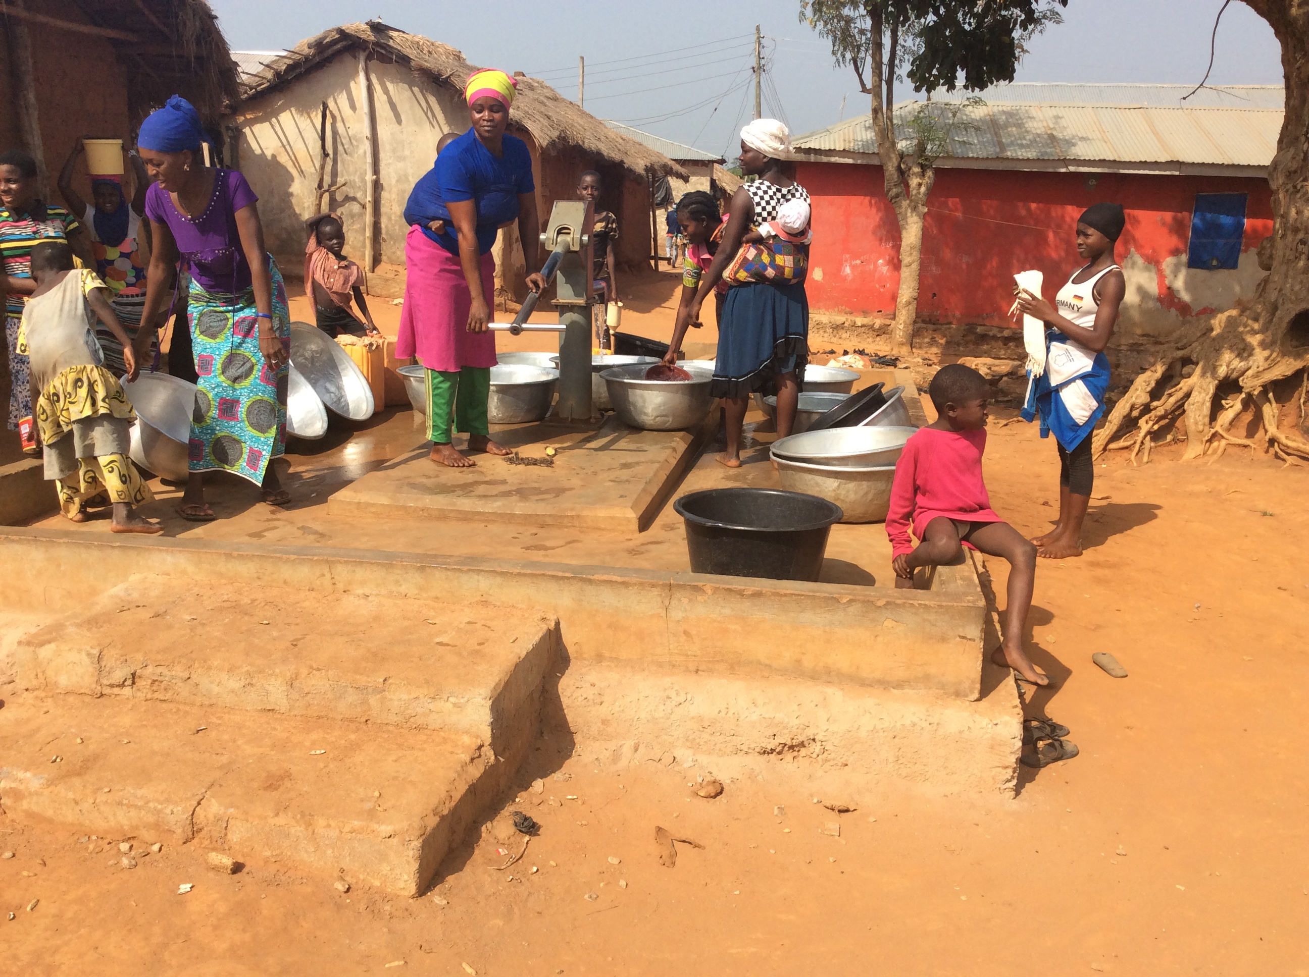

We visited Woraso on 9 December 2010 and talked to community members including the Chief, Nana Kofi Owuse, the Kontihene (Advisor), Mr Issaka Esime, and Mr Ben Kwartin. (pictured below). They told us they were present and able to talk to us because on Fridays they didn’t visit their farms. Most people in the area observe the tradition that ‘on Tuesdays, the land and the river must rest,’ meaning they may not work on their farms. Woraso has substituted Fridays.

We were told that there are around five hundred people, divided into seventy households, in the village. They are farmers, growing crops including beans, cassava, plantain, onions, cashew and tomatoes. They also have a teak plantation. They rarely suffer hunger, and occasionally produce a small surplus to sell at Bosomkyekye market.

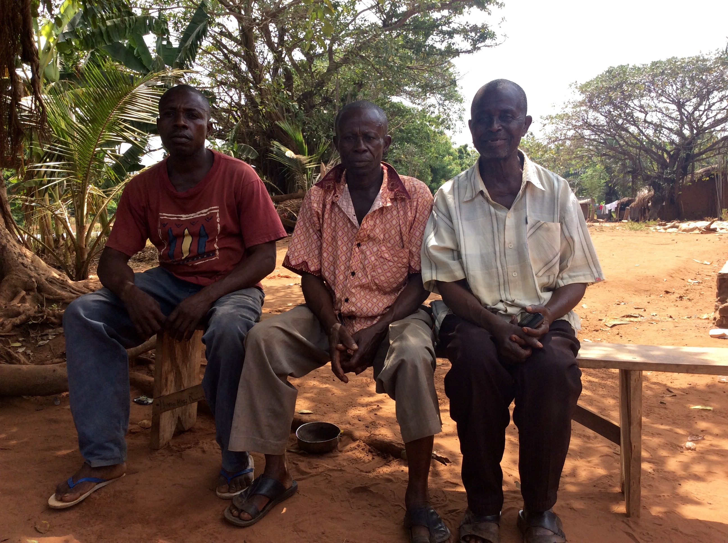
Water and Sanitation.

The village has four boreholes and we thought that their water management was very good. They
charge each household Ghc.1 per month (about 20p), and this money is saved for repair and maintenance.
They also draw water from the Wora River, which never dries up. The community feel they have
enough water.

There are four communal traditional latrines in the village, two for women and two for men. They are cleaned regularly by children under the age of 18 years.

Health

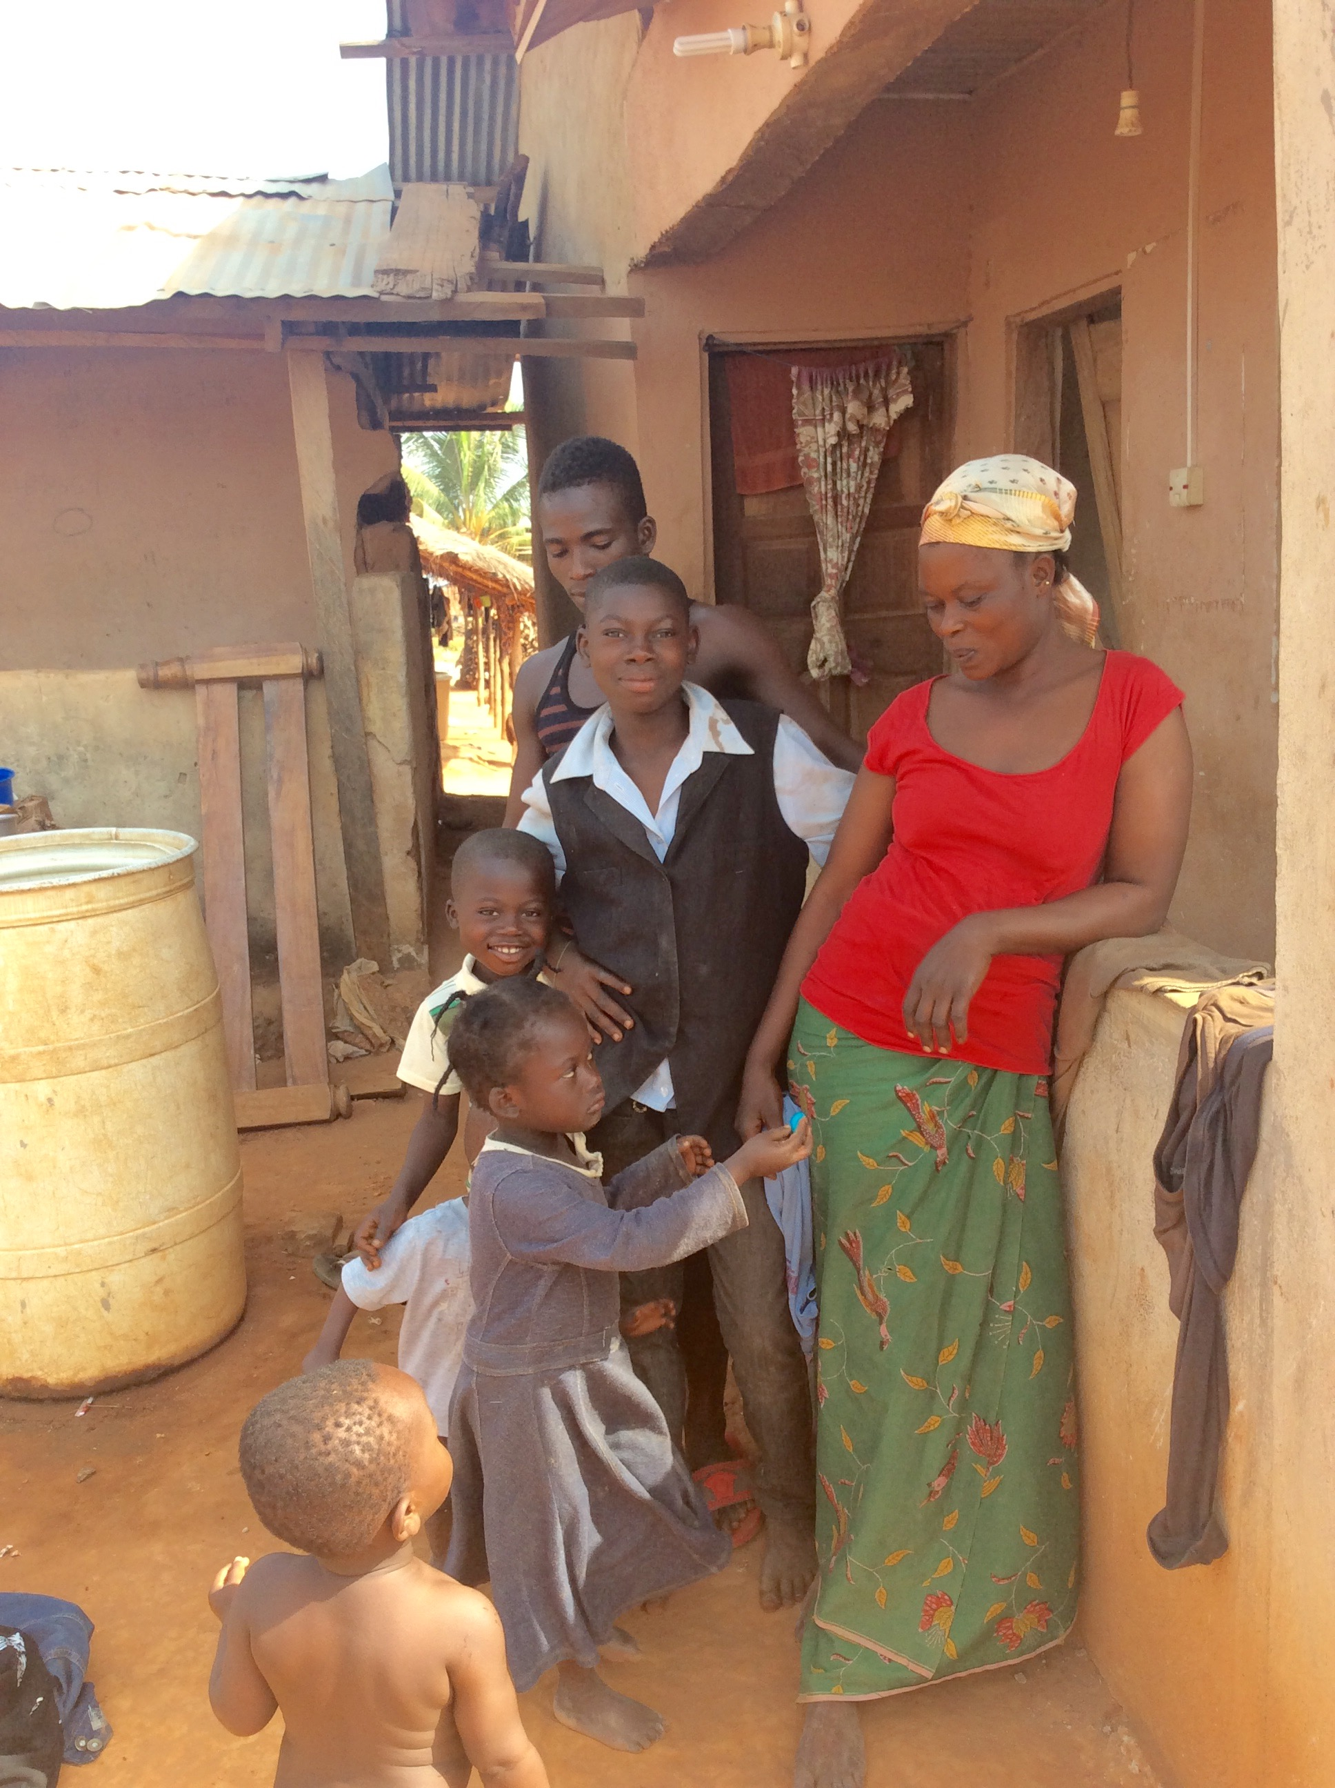
The nearest clinics are at Bosomkyekye, Aduwan or Mampong. The most comment sicknesses are malaria, waist pains (normally caused by carrying heavy loads on the head), flu (seasonal coughs and
colds which come with the Harmattan Wind). There is little
diarrhoea because the water supply is good.

Education

The village has one kindergarten, one primary and one junior high
school. None of these has enough classroom space – many
classrooms have been divided in two.

A few people speak English and about twenty can read and write.

Institutions

The village has two representatives on a five member Unit
Committee, which Woraso shares with the neighbouring village of
Sekruwa. It also has a Committee of Chief and Ekders which works
well. However, the Assemblyman (local authority councillor equivalent) is based in Mampong, which doesn’t make for smooth working.

Miscellaneous

The Pentecostal, Presbyterian, Roman Catholic and Muslim religions are all represented in Woraso.
There are four table top shops and for transport, the village uses tractors, bicycles and motorised tricycles.
The community has a gari mill, which mills, ferments and fries cassava to convert it to its long-life form.
They share their annual festivals with the village of Ninting, which was their original home.

History

The people were warriors for the King of Mampong during the Ashanti War of Conquest circa 1800. Before that, the area was settled by the Gonja tribe, one of the biggest in the Northern Region. During the war, the villagers’ ancestors defeated the Gonja and killed their king.

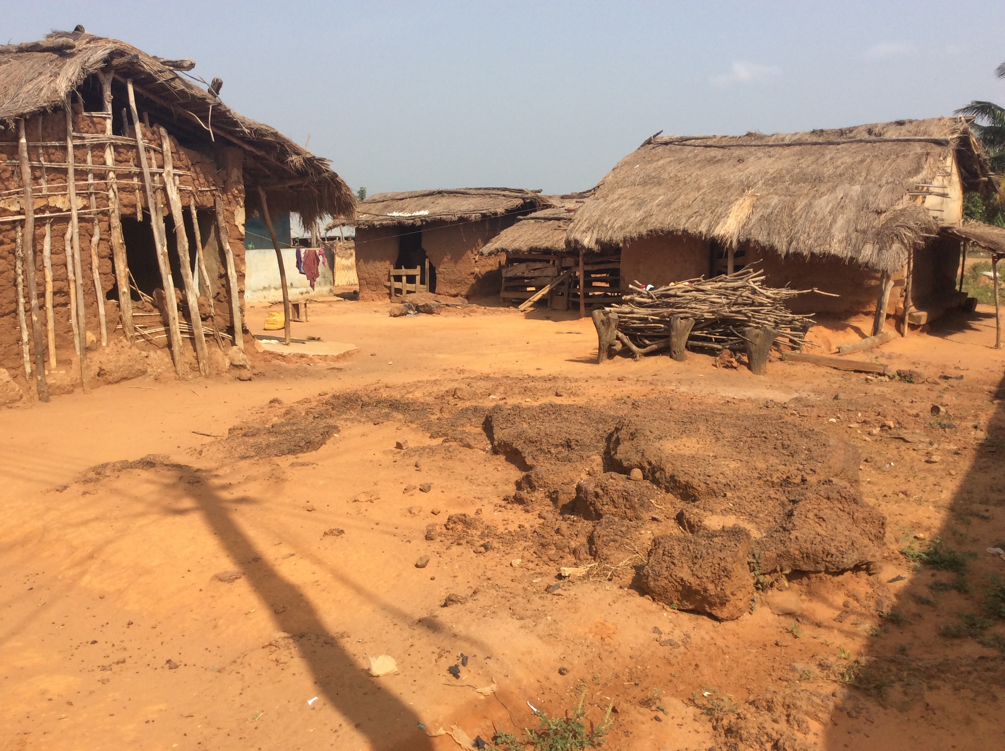
The Gonjas fled – they ran away to the other side of the Volta Lake. The King of Mampong was so pleased about this that he invited the people to take over all the land belonging to the Gonja, and they chose to settle close to the River Wora.

Wish List

a. Latrines
b. A chip compound, ie a small clinic.

