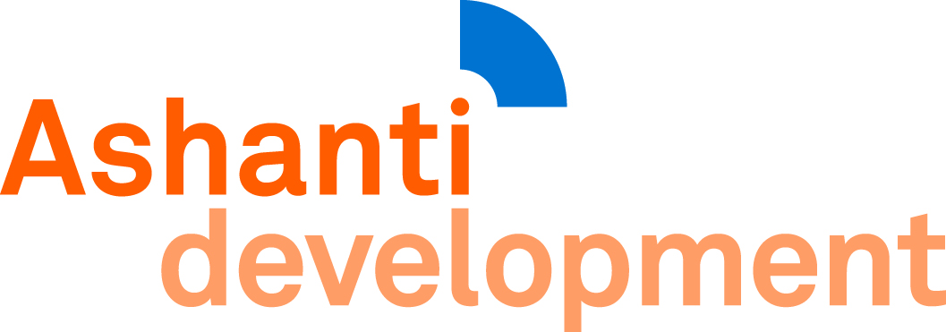

Wonoo Kokomba
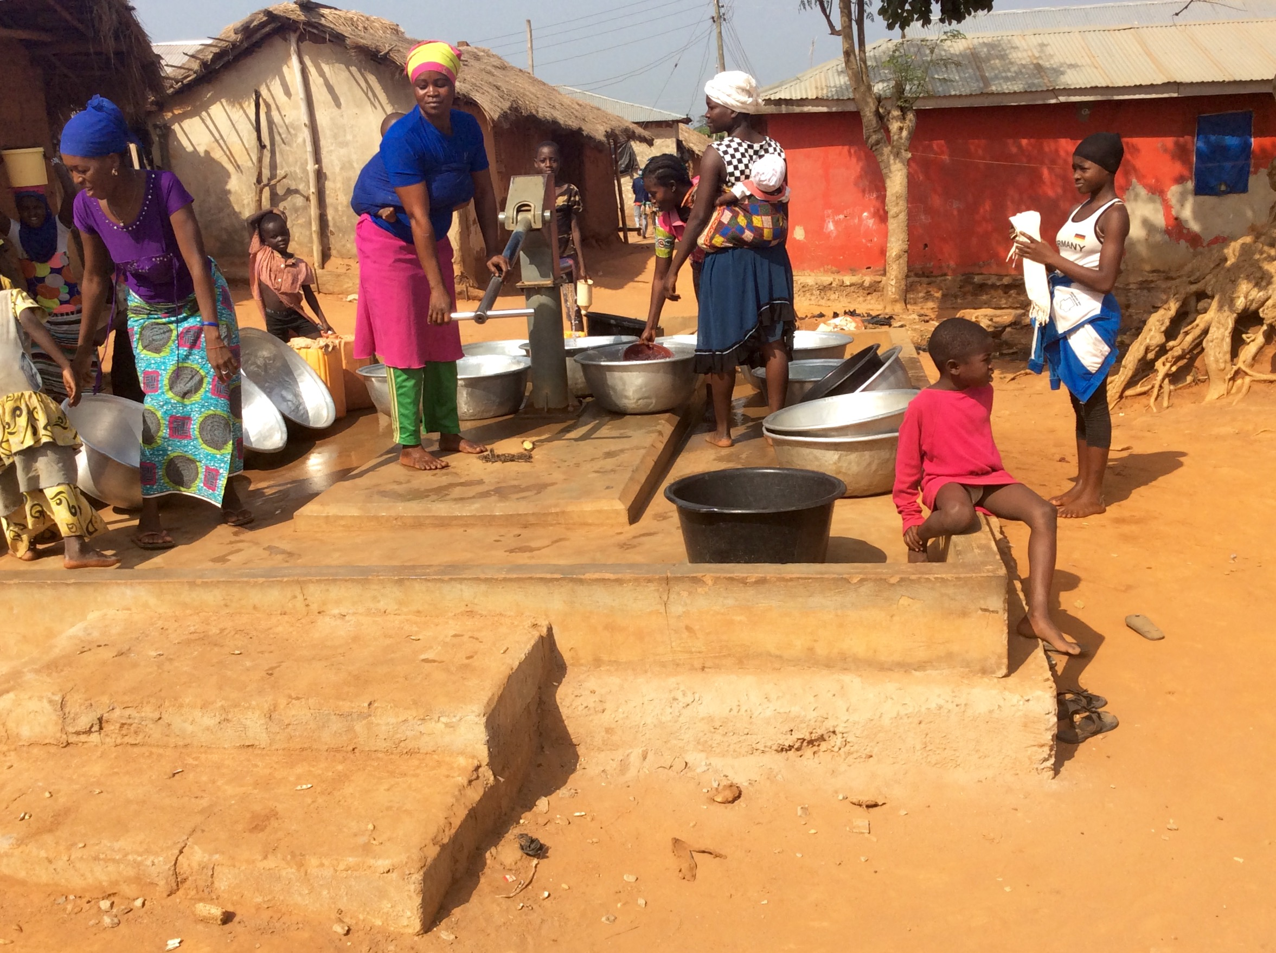

We visited Wonoo on 16 December 2016 and talked to community members including Elder Owusu-Sekyere Seth and Stephen Agyei Kusi (pictured below right).They told us that the population of the whole village was 800, divided into about 70 households. They said it consisted of three distinct areas: the Zongo area (settlers from several tribes from the north); the Kokomba area (from the Kokomba tribe); and the main village, consisting of the majority Ashanti tribe.

This note concerns the Kokomba area.

The Kokombas are settlers who come south from Northern Ghana or Burkino Faso, usually because climate change has made farming in their home country almost impossible. They originally came to Wonoo as seasonal workers, to help on the Ashanti farms, and then stayed on. There are approximately 270 Kokombas in Wonoo, divided into 25 households.

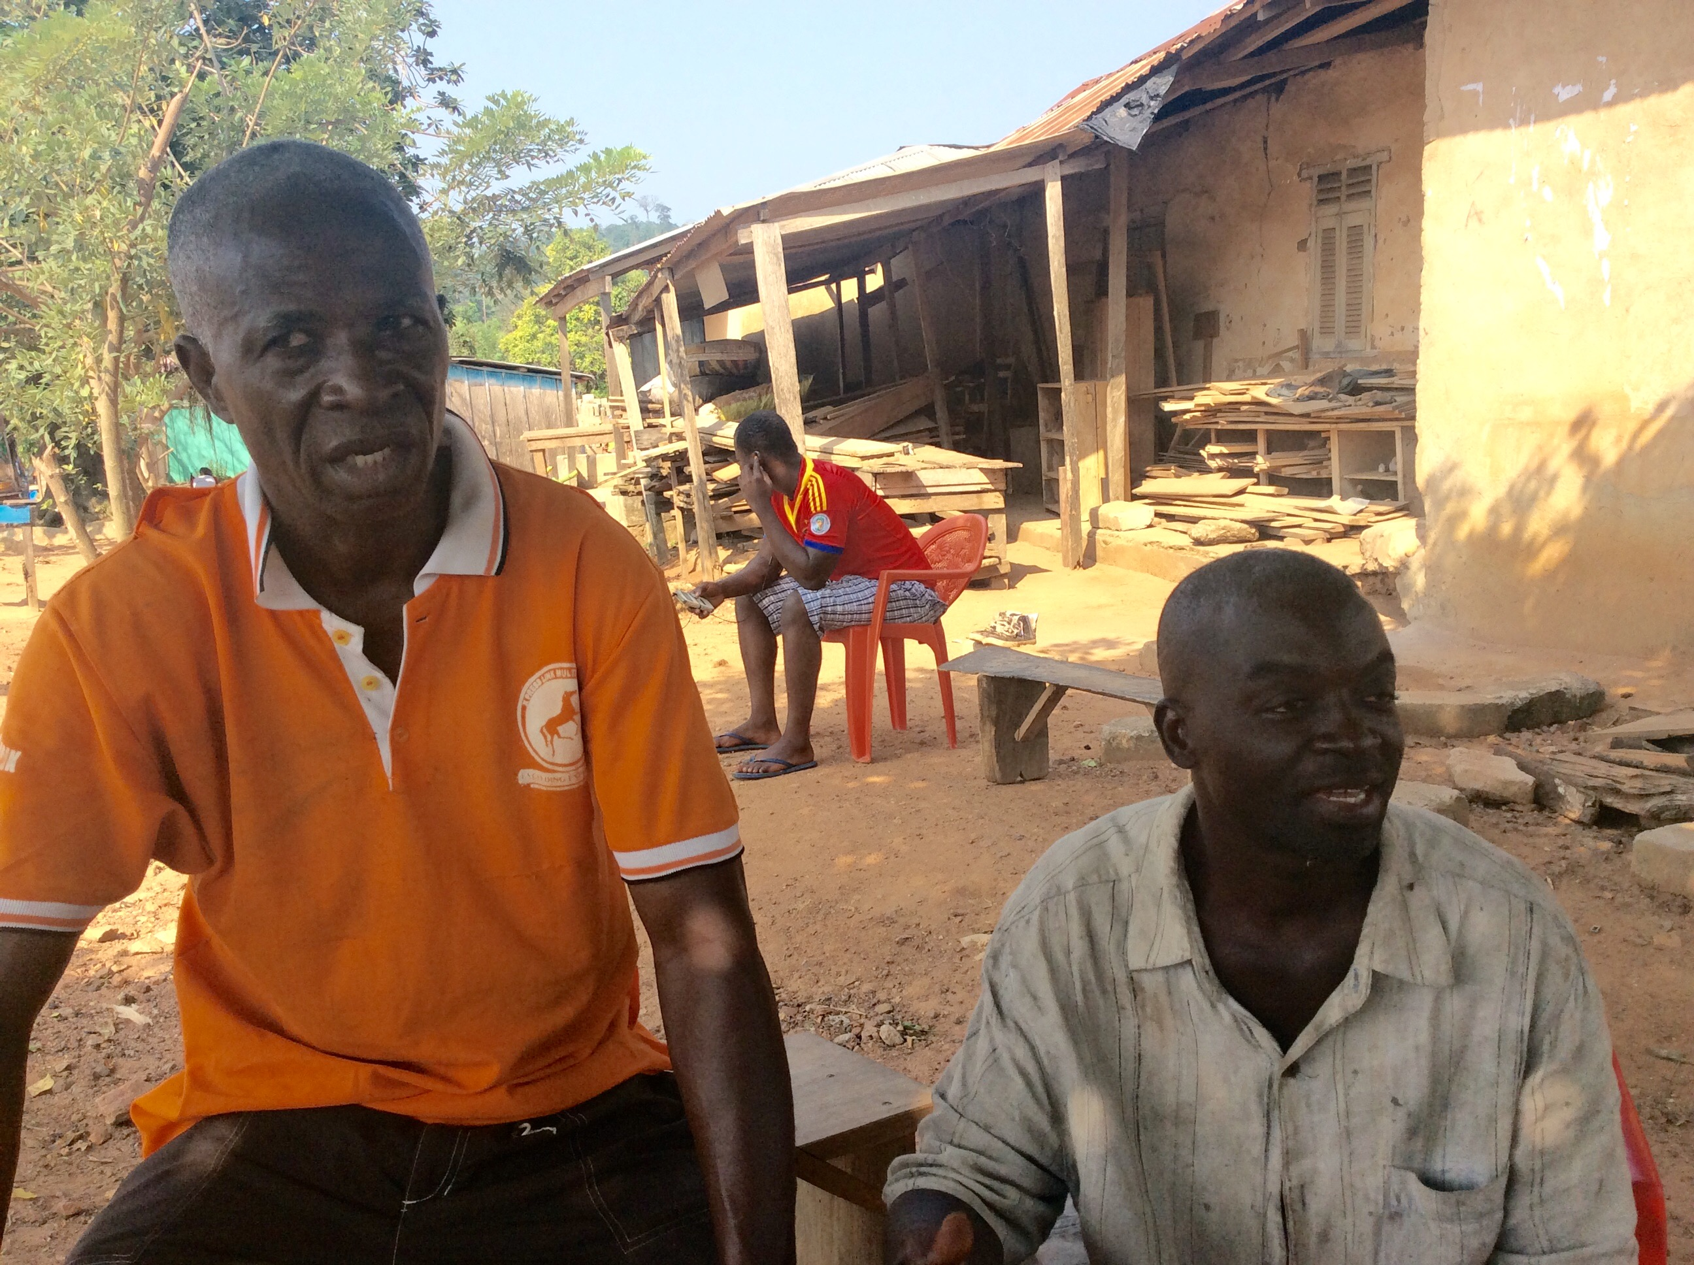
The Kokombas are farmers, growing yam, cassava, corn, bananas, plantain, cocoyam, mango, cocoa and vegetables such as carrots and garden eggs (aubergine). The land is very fertile so there is little hunger, and occasional surpluses are sold at Kunasu or Bodomasi markets.

Water

The three Woono villages have six boreholes. One
is broken, but they don’t bother to mend it because they have plenty of water, and sell it for tankering
and selling in other, drier villages. The Krowan,
Abutia and Asofua Streams are also nearby.

Sanitation

The whole village shares one 16-seater communal latrine, with six cubicles for men and six for women. It is full, and smells terrible and the community is currently building a second. In the meantime, most

people practise open defecation, which is probably serving to pollute the streams.

Education

Wonoo has a primary school with six classrooms; a Junior High School with three; and a single-roomed nursery. There are enough classrooms for the current population.

Health

The nearest clinics are at Kunawu and Efiduase. The main sicknesses are malaria, waist pains (from carrying heavy loads on the head), hernia and diarrhoea.

Institutions

There is a Committee of Chief and Elders covering the whole village, and also a Unit Committee (parish council) which includes Kokomba representatives and also covers small groups of houses located in the bush. There is also a non-functioning Water and Sanitation Committee and a School Management Committee. The assemblyman (local authority councillor equivalent) lives at Kunawu.

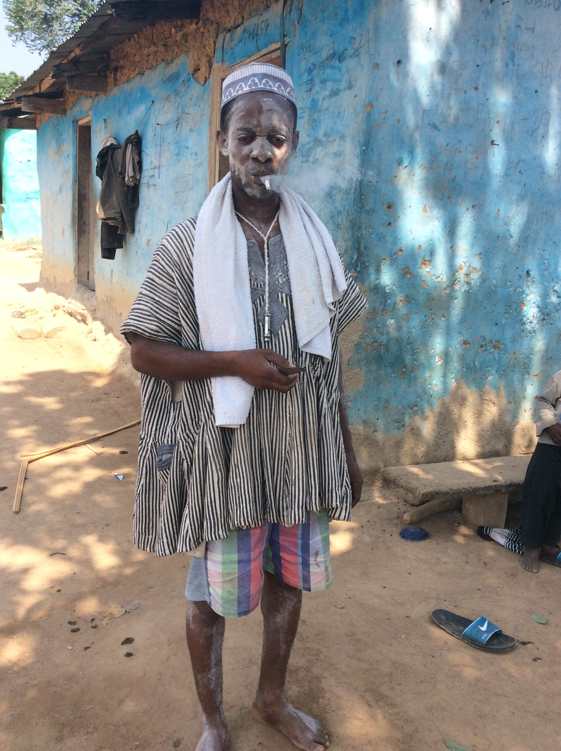
All these groups work well together and the village appears to be well managed. They have even planted teak around the school, which can be harvested when times are hard.

Electricity

Electricity is available because the village is on a main road, and most houses are connected to the grid.

Religion

Wonoo includes Muslims, Christian, and traditional religions. (The religious leader in the photo went into
a trance soon after meeting us, during which he spoke a language from the Volta Region.)

Wish List
a. latrines
b. chip compound (small clinic)



