

MANTUKWA

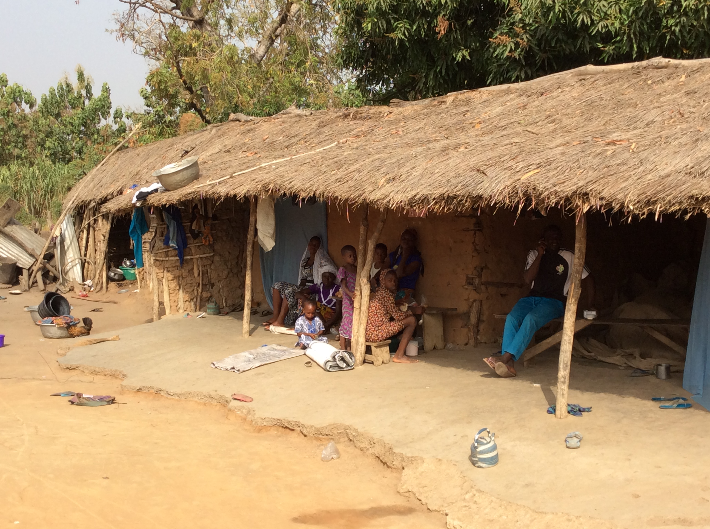

This note is based on an interview with the community on 22 January 2016

Mantukwa is a village of some 800 people, divided into 75 households. It is situated 20km north of the District Centre at Nsuta in Sekyere Central (local authority) District.

The people of Mantukwa are subsistence farmers. Their principal crops are maize, cassava, corn, yam, plantain and groundnuts. Above all they are known for the high quality of their maize, which they sell at Nsuta market.

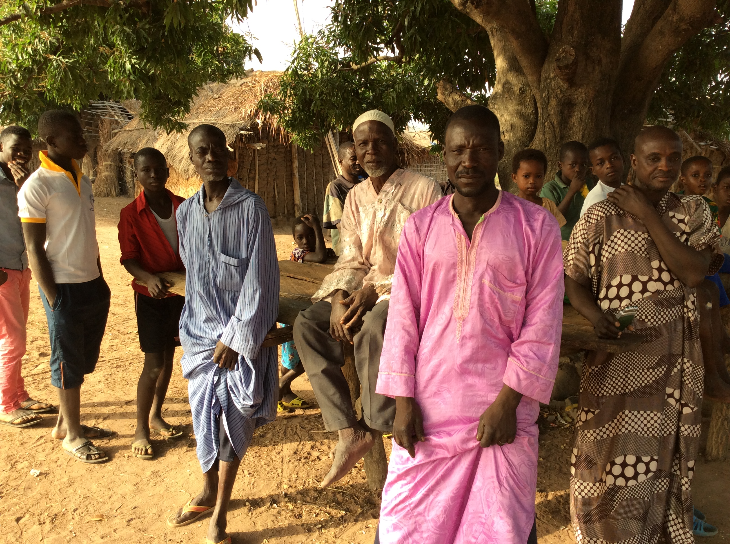
Water and Sanitation
There are two boreholes, but one of them is broken. Even two aren’t enough to serve the whole community, so they also draw polluted water from a nearby stream.

There are no latrines in the village, and people defecate in the bush, which in time will serve to pollute the stream still further, if it doesn’t already do so.

Education
For primary classes 1, 2 and 3, children go to school at a neighbouring village, Aserenkwanta, about two kilometres away. For classes 4, 5, 6 and Junior High School, they go to Nkudjua, which is four kilometres distant.

Health
The community told us they suffered constant ill health because of what we considered to be water-related disease. The nearest clinic is at Nsuta. Women experiencing difficult labour have no option but to be transported there by motor cycle, and many don’t survive the experience.

Organisation
The village has an elected Unit Committee and a Committee of Chief and Elders.

Miscellaneous
Every household has a mosquito net as a result of a recent government initiative to provide them universally. The houses are made of wood with thatched roofs, and look very different from those of the local Ashantis. The internet works.

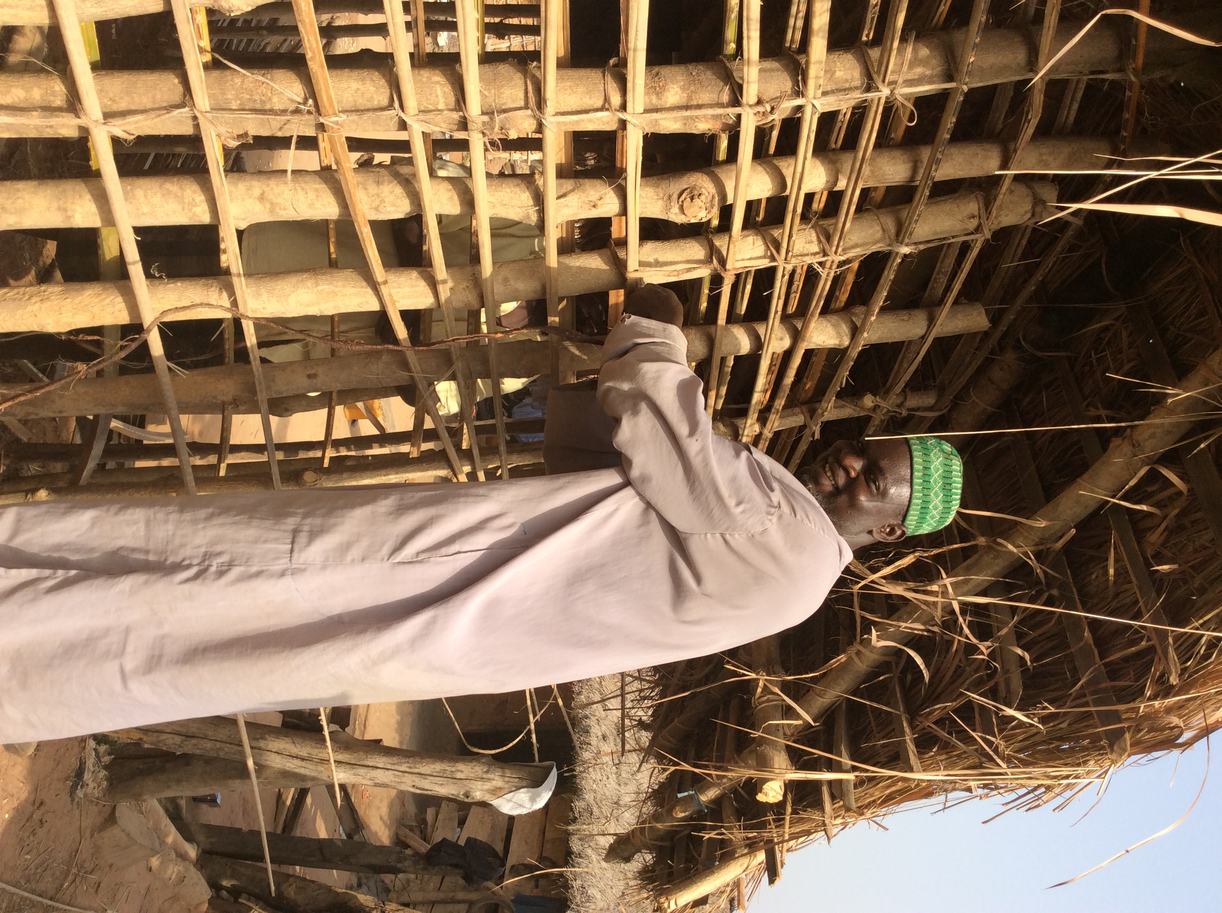
Religion
The people are mainly Christians and Moslems. The Christians go to church in Aserenkwanta while the Moslems have built themselves a mosque. There is also a witch doctor.

History
The people of Mantukwa are from the Dagomba tribe and Dagbani is their language. They originated in the north of Ghana, and came south some thirty years ago when climate change made farming difficult. They settled first in the neighbouring village of Asarenkwanta.

In their first season in Asarenkwanta, their houses got burned down. The same thing happened the second year, so they moved away and settled in Mantukwa.

Mantukwa means we came here for a good reason.

Mantukwa’s Wish List
1. Latrines
2. Another borehole
3. A nursery for the children.
4. Microcredit

