
EXAMPLE

HWEIDIEM
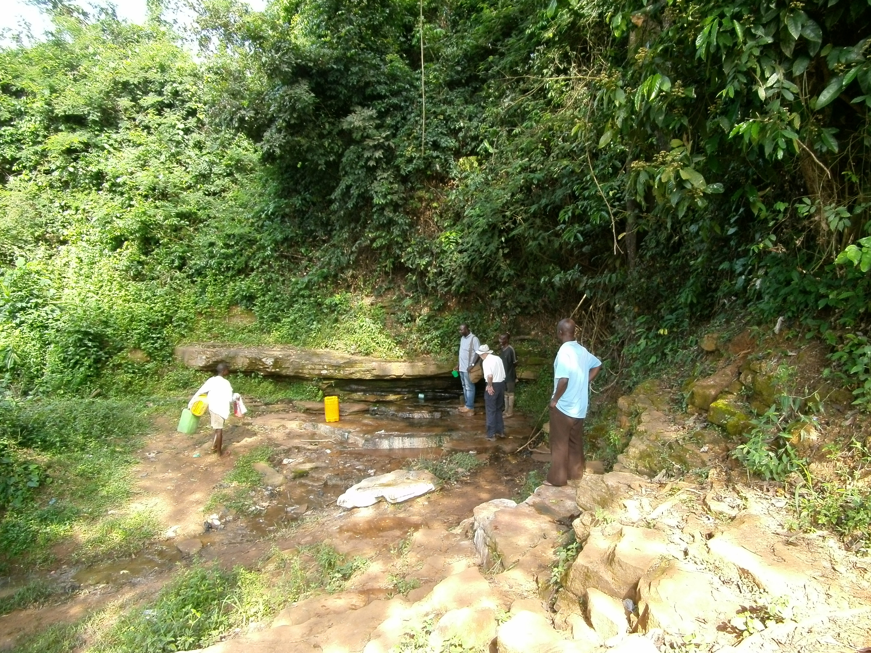

This note is based on visits to the village and interviews with the community on 13 November 2012

Hweidiem is a village of some 600 people, divided into fifty-five households. It is situated 10km west of Mampong in the Mampong Municipal (local authority) District.

The people of Hweidiem are subsistence farmers. Their principal crops are cassava, yam, plantain, groundnuts and cocoa. The land is good, and they sell a small surplus at Nsuta market as well as selling to market women, who come to the village to buy. They also make cocoyam and vegetables such as tomatoes, cabbage and carrots.

We were told that the principal diet is fu-fu (plantain and yam, cooked and pounded in a mortar) and fish, and that meat was only eaten at Christmas.

The chief is called Nana Kwaku Sarfo Adu Denteh. There is a Unit Committee (elected village committee) but no Water and Sanitation Committee.

Water and Sanitation
The community draws water from the Mesidae stream, which is quite close, is very clean and which doesn't dry up during the dry season.

Their Member of Parliament has recently donated a new KVIP. There are also two traditional latrines, one of which is pictured below.

Health/ Schools
Nsuta Clinic is the nearest place for the people to obtain health care. We were told that the principal sicknesses were malaria and diarrhoea.

There is a primary school in the village but the nearest Junior High School is at Ningting, about 2km away.

Other
The main religions in the village are Pentecostal, Roman Catholic, Presbytarian and Muslim. There is no witchdoctor.

When we asked how far members of the community had travelled away from home, we were told that some had been to Kumasi and one or two had even been to Accra.

For the future the community told us that above all they would like household latrines and proper school buildings.

History
The people of Hwediem originated from Takyiman in the Brong Ahafo region of Ghana. One day the King of Mampong visited his friend, the King of Takyiman (Nana Ameyaw), who asked his sister to cook for the King of Mampong.

The food was so delicious that the King of Manpong asked the King of Takyiman for his sister's hand in marriage. The King of Takyiman accepted his friend's and asked one of his brothers, Nana Ntiamoah, to accompany his sister to Mampong.

Nana Ntiamoah, discovered a very fertile piece of land and asked the King of Mampong to allow him to settle there and farm. This was agreed. Nana Ntiamoah named the village Hwediem because the vegetation in the area was dominated by wild sugar cane and the local name for sugar cane is ahwedie. So Hwediem means a village located in the midst of sugar cane.
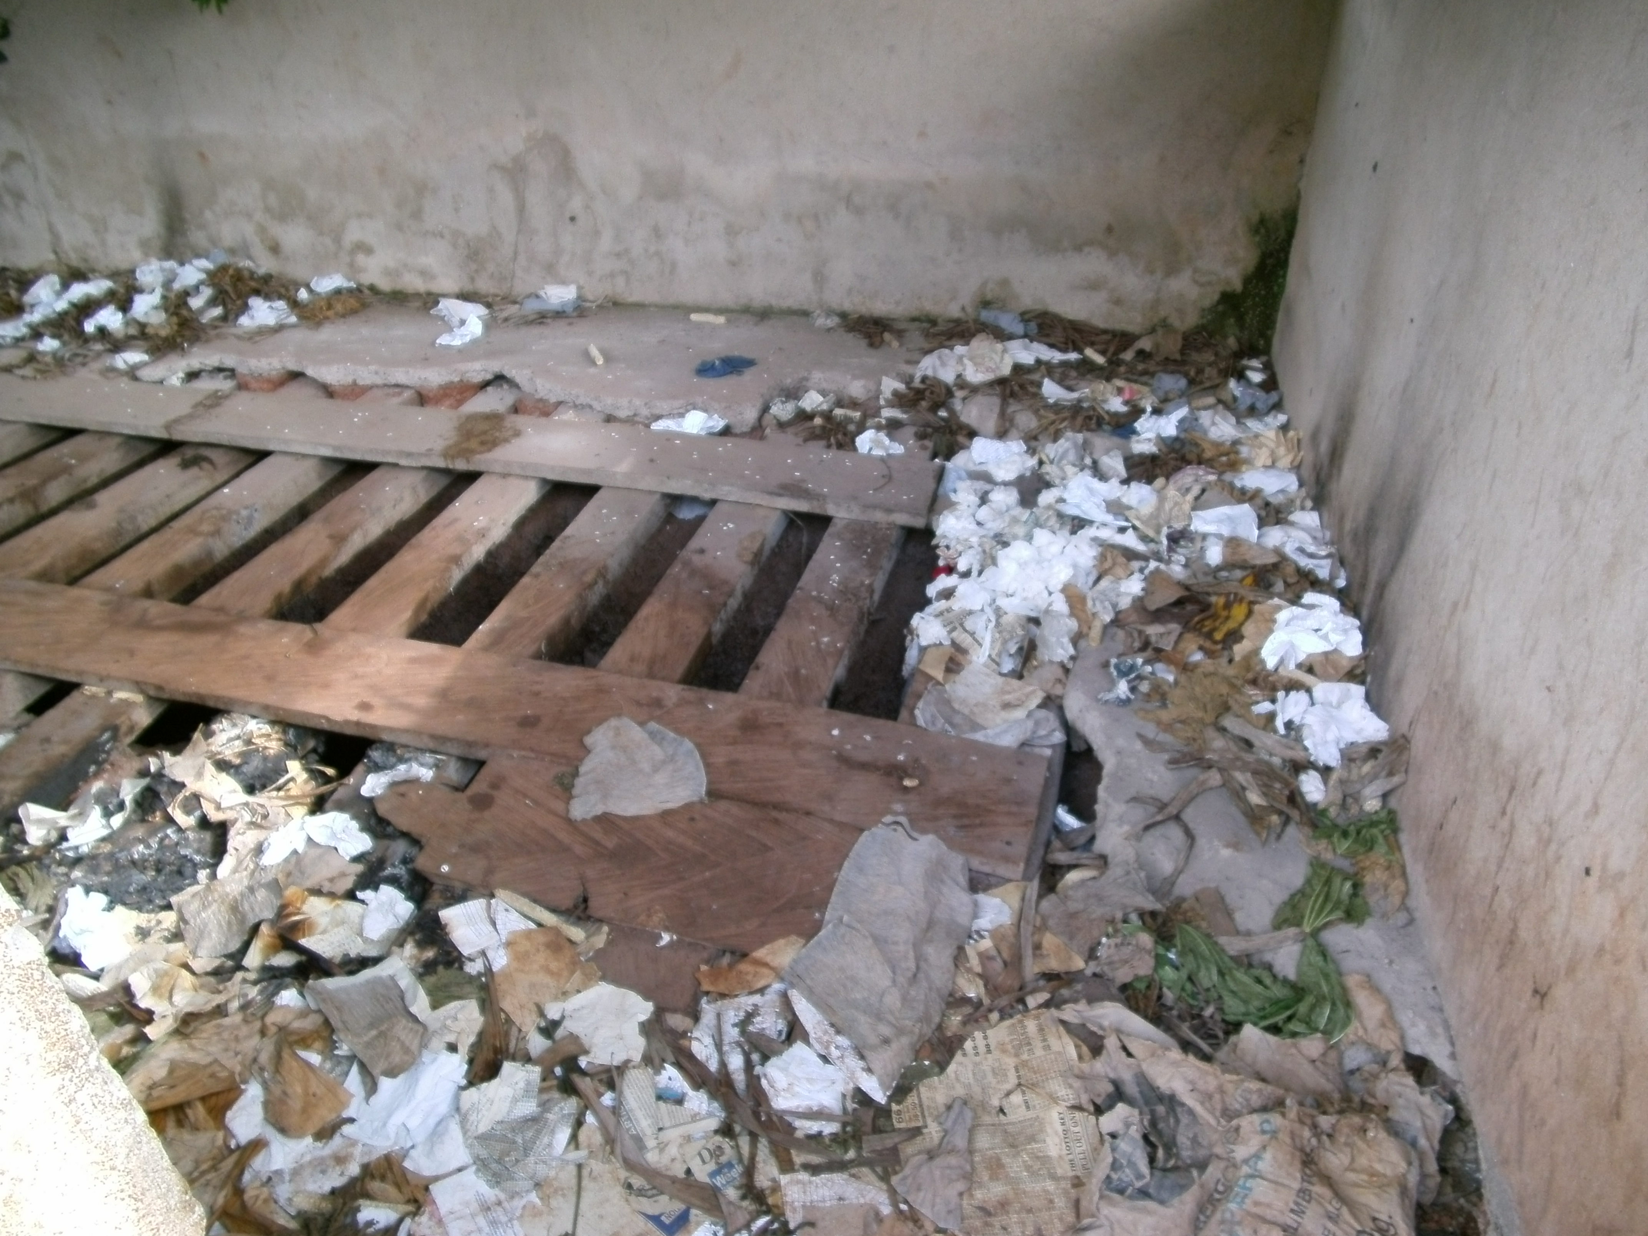

'Nana' means 'Chief'
Kumasi Ventilated Improved Pit Latrine. This is a communal latrine, with four to six seats each for men and women.

