

Ebuoso
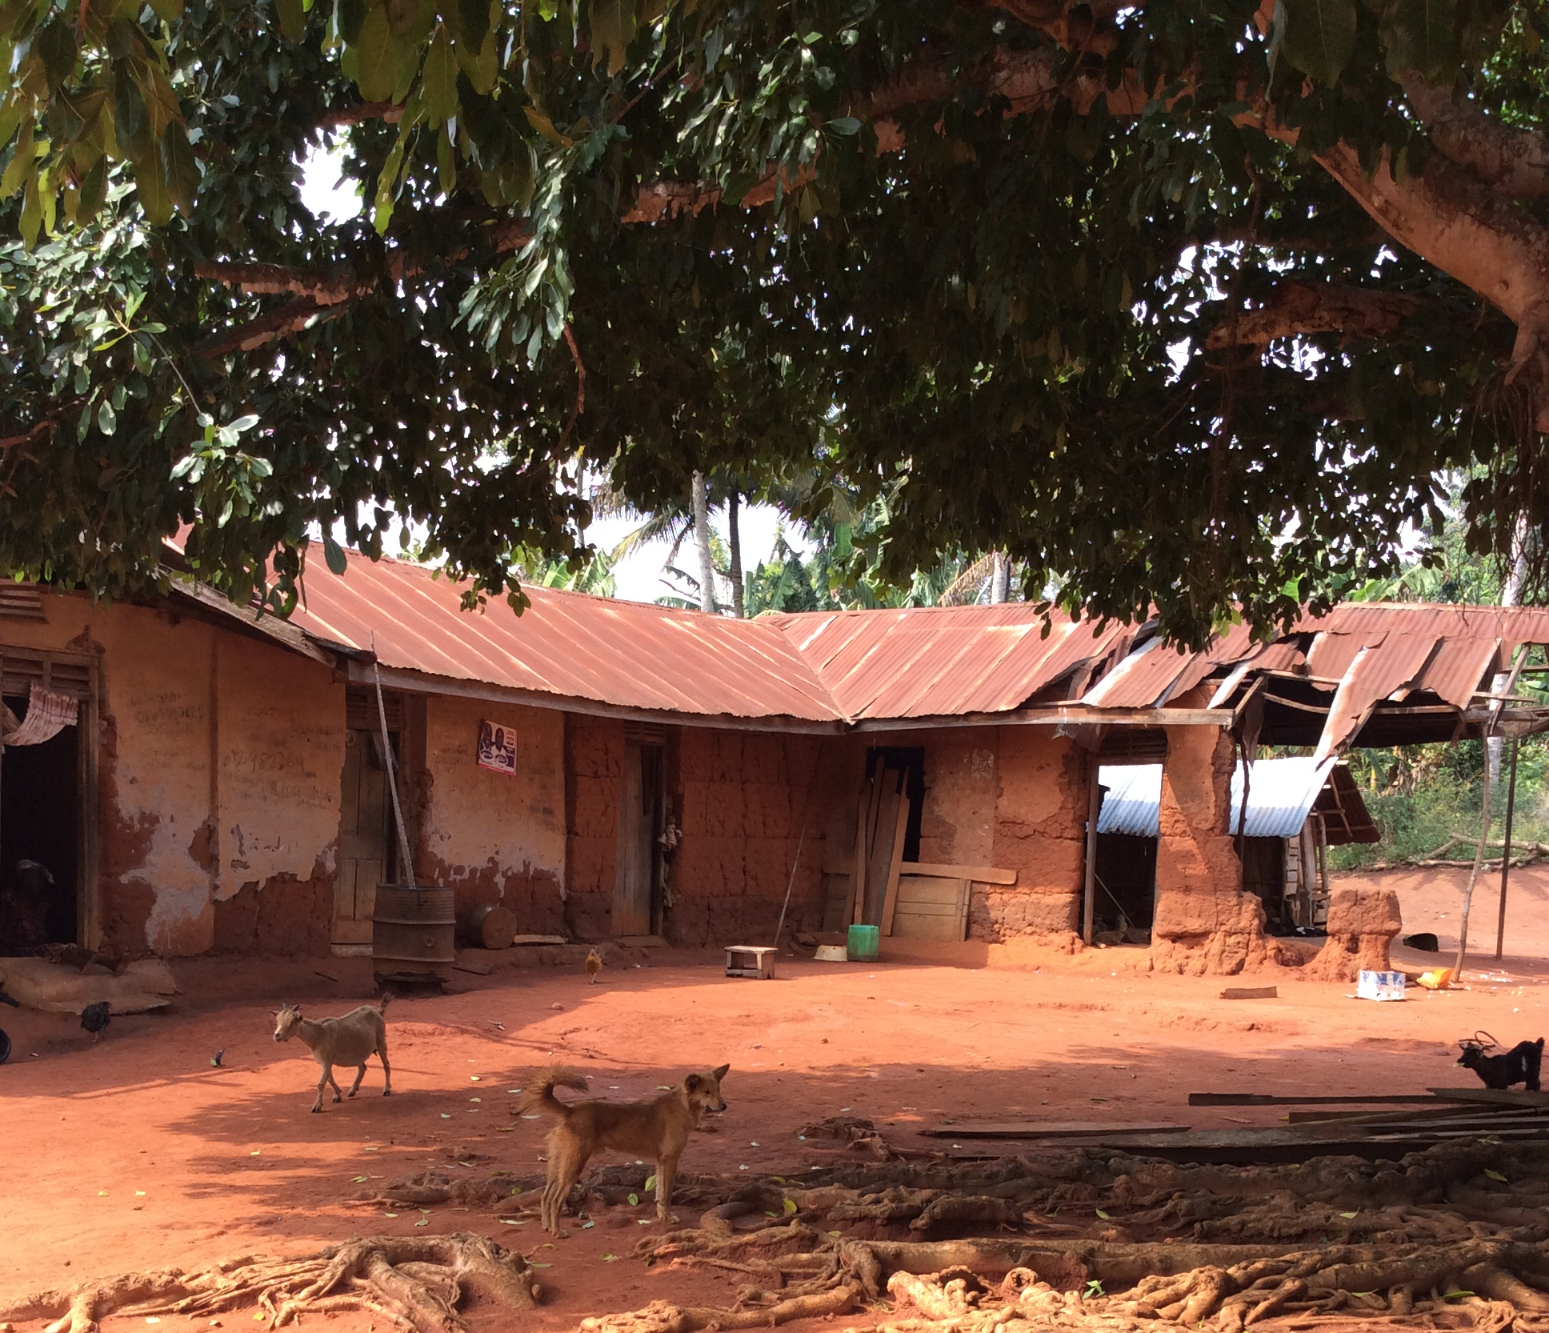

We visited Ebuoso on 17 December 2016 and talked to community members including Mr Kwasi Mensah, below right.

We were told that this tiny hamlet consists of some fifty people, divided into about eight households. They are all farmers, growing crops including maize, groundnuts, plantain, yam, cocoyam, mango, cassava, carrots and garden eggs (aubergine). The land is very good so everyone has enough to eat, and the occasional surplus is sold at Ejura or Mampong Markets.

Water and Sanitation

The people draw water from the Asuafo Spring, and they consider the water to be very clean.
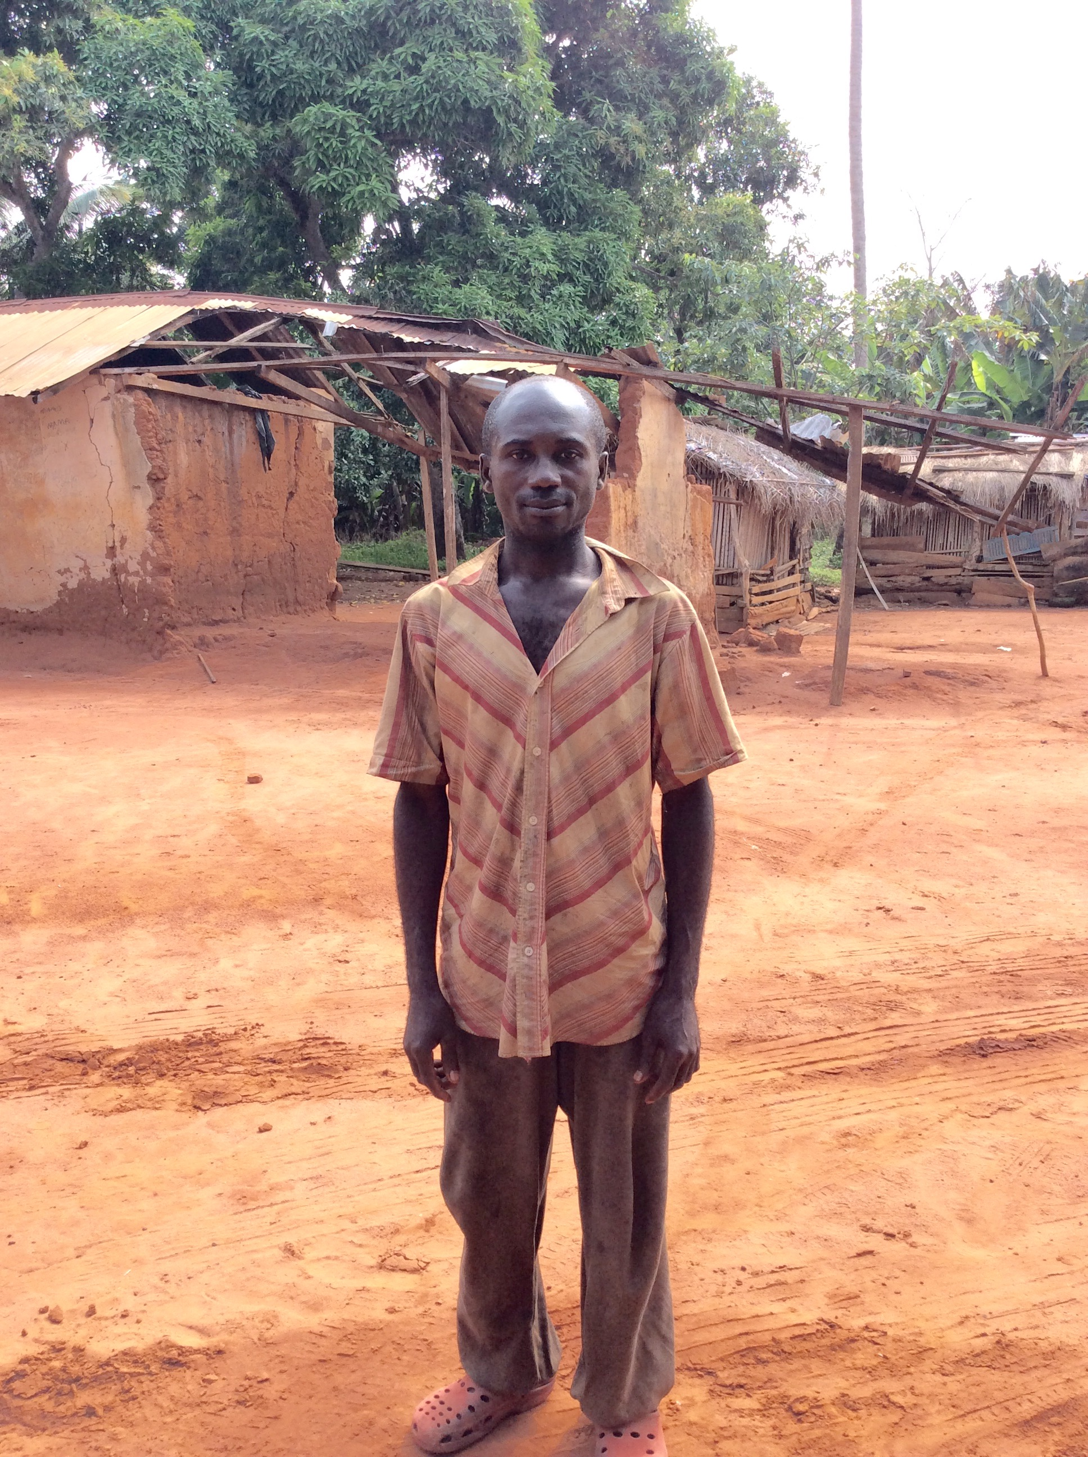
There is one traditional pit latrine in Ebuoso.

Education

The children go to school in Brengo village, which is a short walk away.

Health

The nearest clinics are at Assam and Mampong. The most common diseases are malaria, diarrhoea, and coughs and colds.

Institutions

There is no village chief. The village is governed by a Unit Committee (parish council) which the community has set up outside government provisions. They are also represented on a statutory Unit Committee which is shared with Brengo Village. (Statutory Unit committees cover several villages, and many people believe they are are spread too thinly to be effective.)

Religion

The community are all Christian and go to church in Brengo village.

History

We were told that the village is older than Mampong town, and that once it was the residence of the King of Mampong. People eventually left it because it is not on the main road. Many of them now live in Mampong.

Wish List

a. latrines
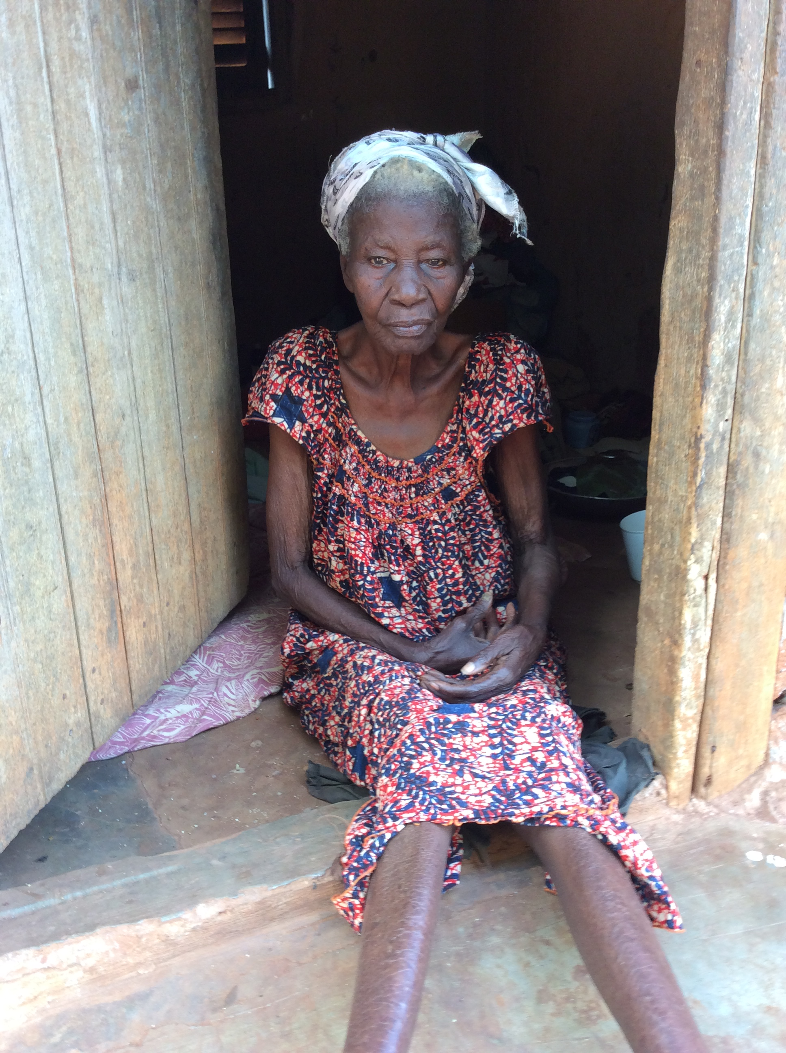
b. farm support



