

BOBIN

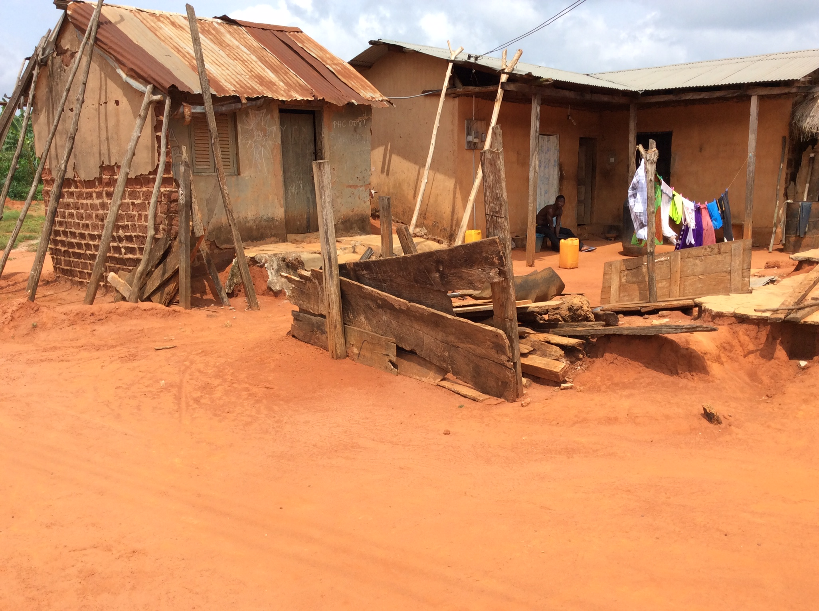

We visited Bobin on 20 July 2015, and spoke to Yaw Ofori, the Chief's brother. We were told that the village consisted of 500 people, divided into 48 houses. They were farmers, and grew mango, green peppers, vegetable, plantain, ground nut, yam, cocoyam and cassava, and ate meat or eggs only once a year at Christmas. They owned more land than they could use and it was good for farming.

Water, Sanitation and Electricity
The villagers draw water from the Awonsua Stream and also have three boreholes, possibly drilled by the Millenium Development Authority. Only one of which was working.

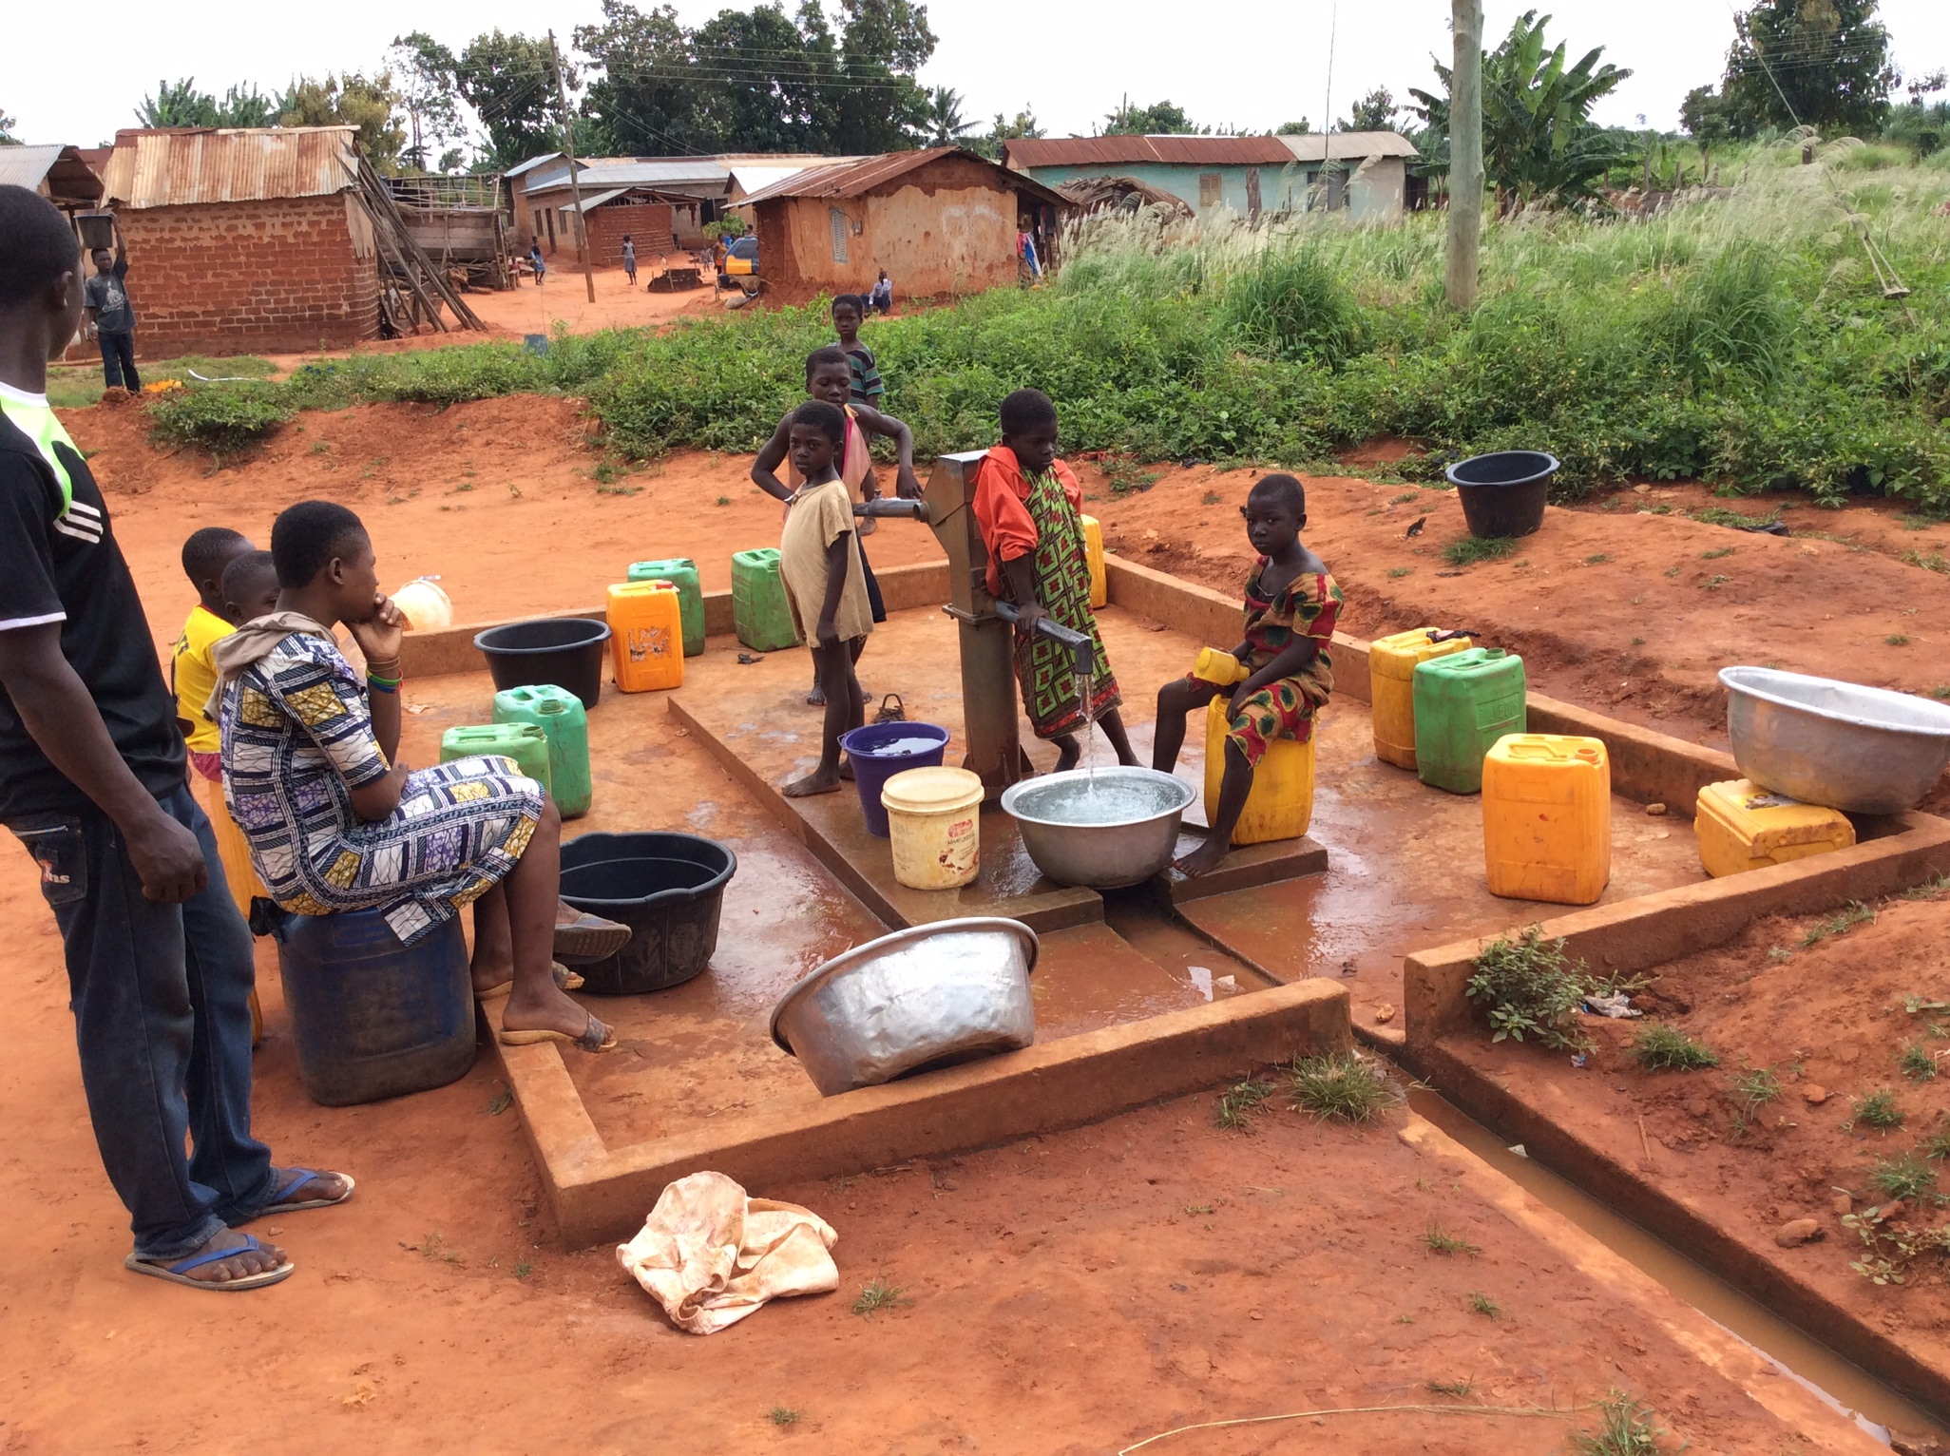
The village had two communal pit latrines, three household latrines and two dumping sites.

Electricity is gradually being extended along all the principal roads in Ghana. We were told that electricity had been available to Bobin for about two years. There was a weak Airtel signal.

Education and Health
Bobin shares a primary school-kindergarten with the neighbouring village of Nkwanta.

We were told the most common sicknesses were malaria and diarrhoea, and that the nearest health centre was Mampong Hospital.

Organisation
The village shares a Committee of Chief and Elders with Nkwanta village. They also share an elected Unit Committee which has a total of five members, of which two represent Bobin.

There is also a Water and Sanitation Committee, a Parent-Teacher Association and a School Management Committee. The Assmblyman - equivalent to a local authority councillor in the UK – who represents several villages on the District Assembly - comes from Bobin, but didn't get on with the Chief and Elders and so was unlikely to be re-elected.

Religions
Villagers were members of the following churches: Presbytarian, Seventh Day Adventists, Pentecostal, Anglican and Muslim. There were also two witchdoctors.

History
The community used to live in Ayasi, but left it because of persistent wars. When they arrived in this area, they asked the King of Mampong to give them some land and accidentally discovered there was a family relationship. In consequence, he told them to come and live in this area, near a big rock. Bobin means 'live close to a rock.'

We were told the whole area was noted for this beautiful rock. In the olden days, if there was a water shortage, the Chief would 'perform oracles' and water would come.

Wish List
The villagers' wish list was for household latrines, a better water supply and a kindergarten.



