

ANKAMADUA

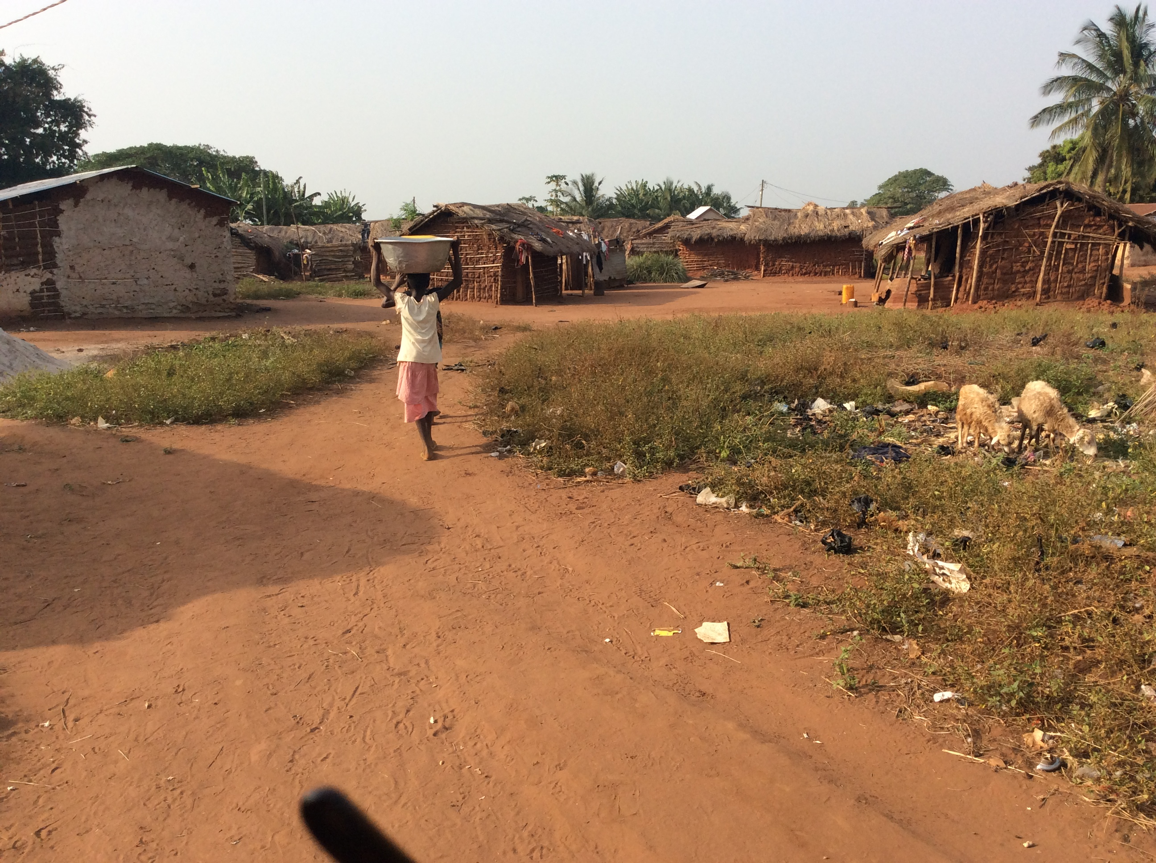

This note is based on a visit to the village held on 10 December 2016, and discussions with the community including Assemblyman Maxwell Frimpong, pictured below.

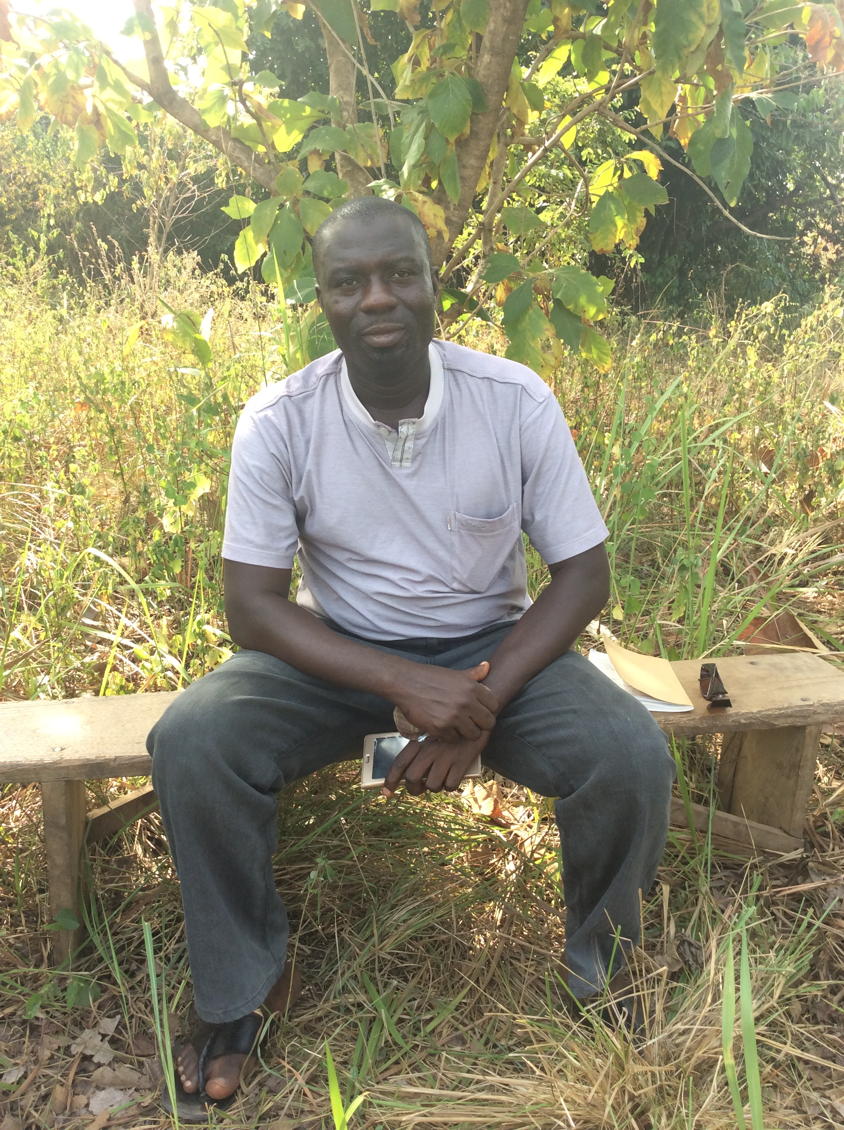
We were told that the population is around 600, divided into eighty households. They are all farmers, producing cassava, corn, yam and vegetables such as garden eggs (aubergines), carrots and tomatoes. Most eat meat only once a year, at Christmas, and their main source of protein is small quantities of dried fish and groundnuts.

There is no gari mill or corn mill in the village.

Water and Sanitation
The community has three boreholes, all broken. They also draw water from the Dida River.

There is one traditional communal latrine, which is full, as well as two half-full KVIPs. Most people practise open defecation.

Health and Education
Because the nearest access to healthcare was so far, Ashanti Development has recently built a new clinic at Ankumadua (see right). We were told that the most common diseases are malaria and diarrhoea. Everyone in the village sleeps beneath a mosquito net.
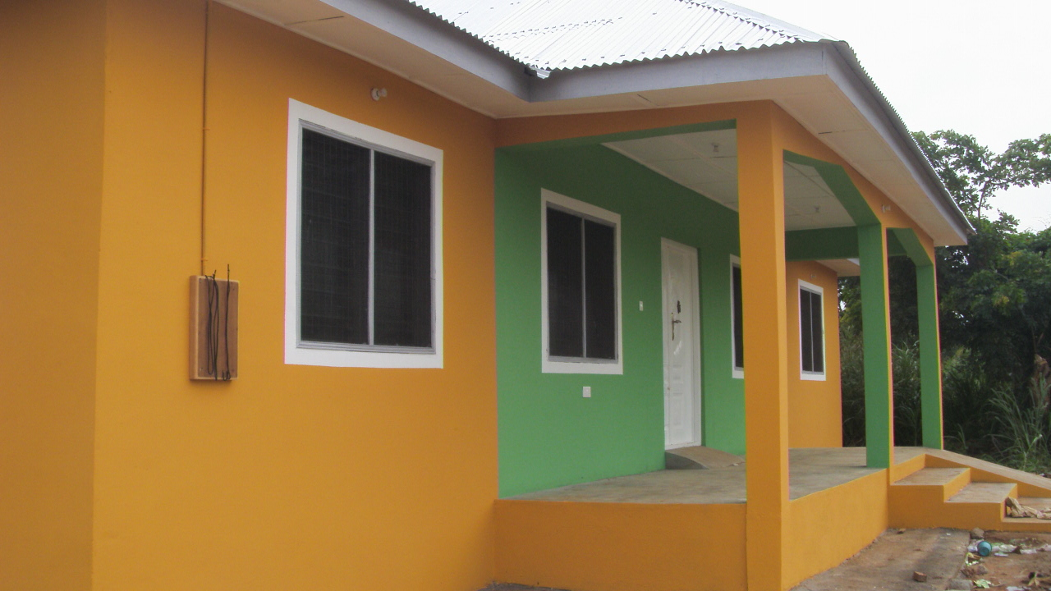
There is one Primary School with six
classrooms and one Junior High School with
three. Neither of these schools has enough
classrooms for the number of children, and
there is no Kindergarten.

About one in three of the community speaks
English. There is no internet connection.

Institutions
There is a Chief and Elders Committee, and
a Unit Committee which extends to three
other villages. Because it is too thinly stretched to look after Ankamadua’s interests properly, the village has added three new members, and the enlarged Committee works well.

The Assemblyman covers Dagati as well as Ankamadua. There is a Water and Sanitation Committee (WATSAN), which doesn’t work well. There is also a Parents and Teachers Association.

Miscellaneous
Ankamadua’s main religions are Roman catholic, Methodist, Seventh Day Adventists, Pentecostal, Muslim, and there is one influential witchdoctor. There are three shops, including a small pharmacy, and two cars. There are about twenty bicycles and ten motor bicycles.

History
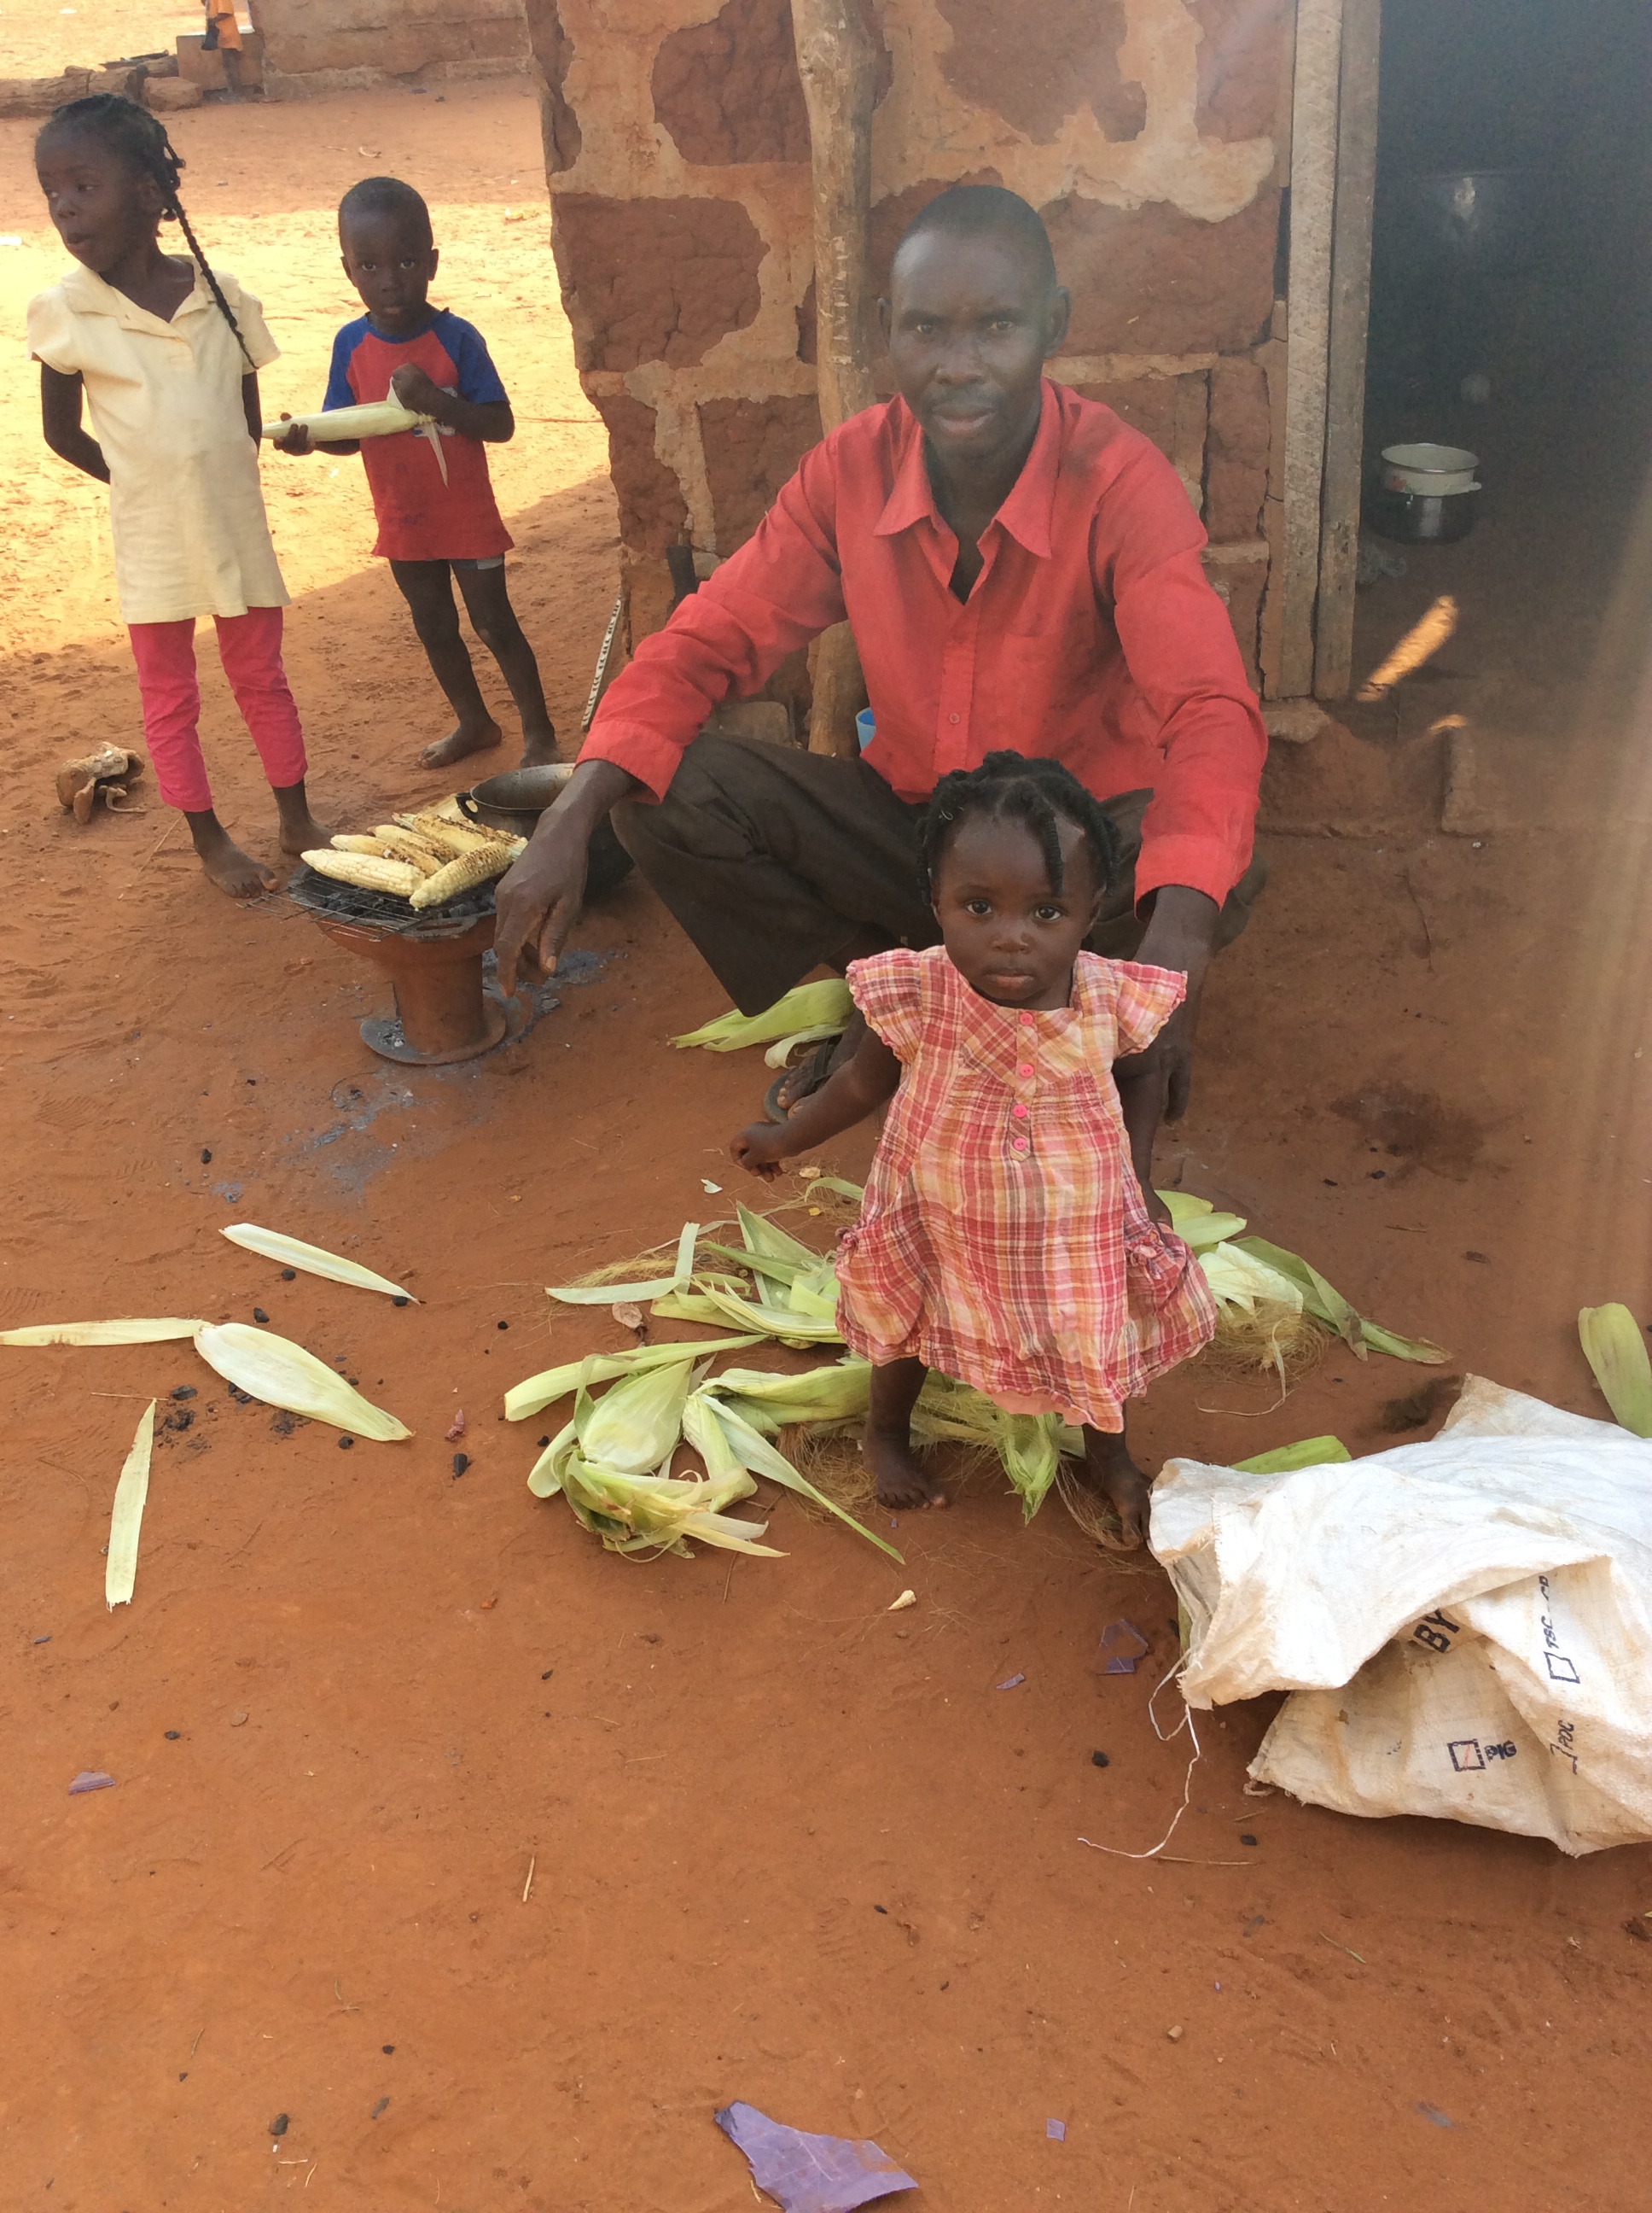
The village founder was called Ankada. He was a hunter for the King of the Ashantis. The whole area was full of small deer called duikers or adua, and
the king loved their meat so Ankamada came often to
the area. Finally, he set up a camp, to save himself the
travel.

After a while, Ankamada started farming and many
people joined him until a little village had formed. The
village is named after Ankamada and the duikers or
Aduas.

Wish List

Above everything else, the village would like household
latrines.

An assemblyman is roughly equivalent to a local authority councillor.

