

JANSA
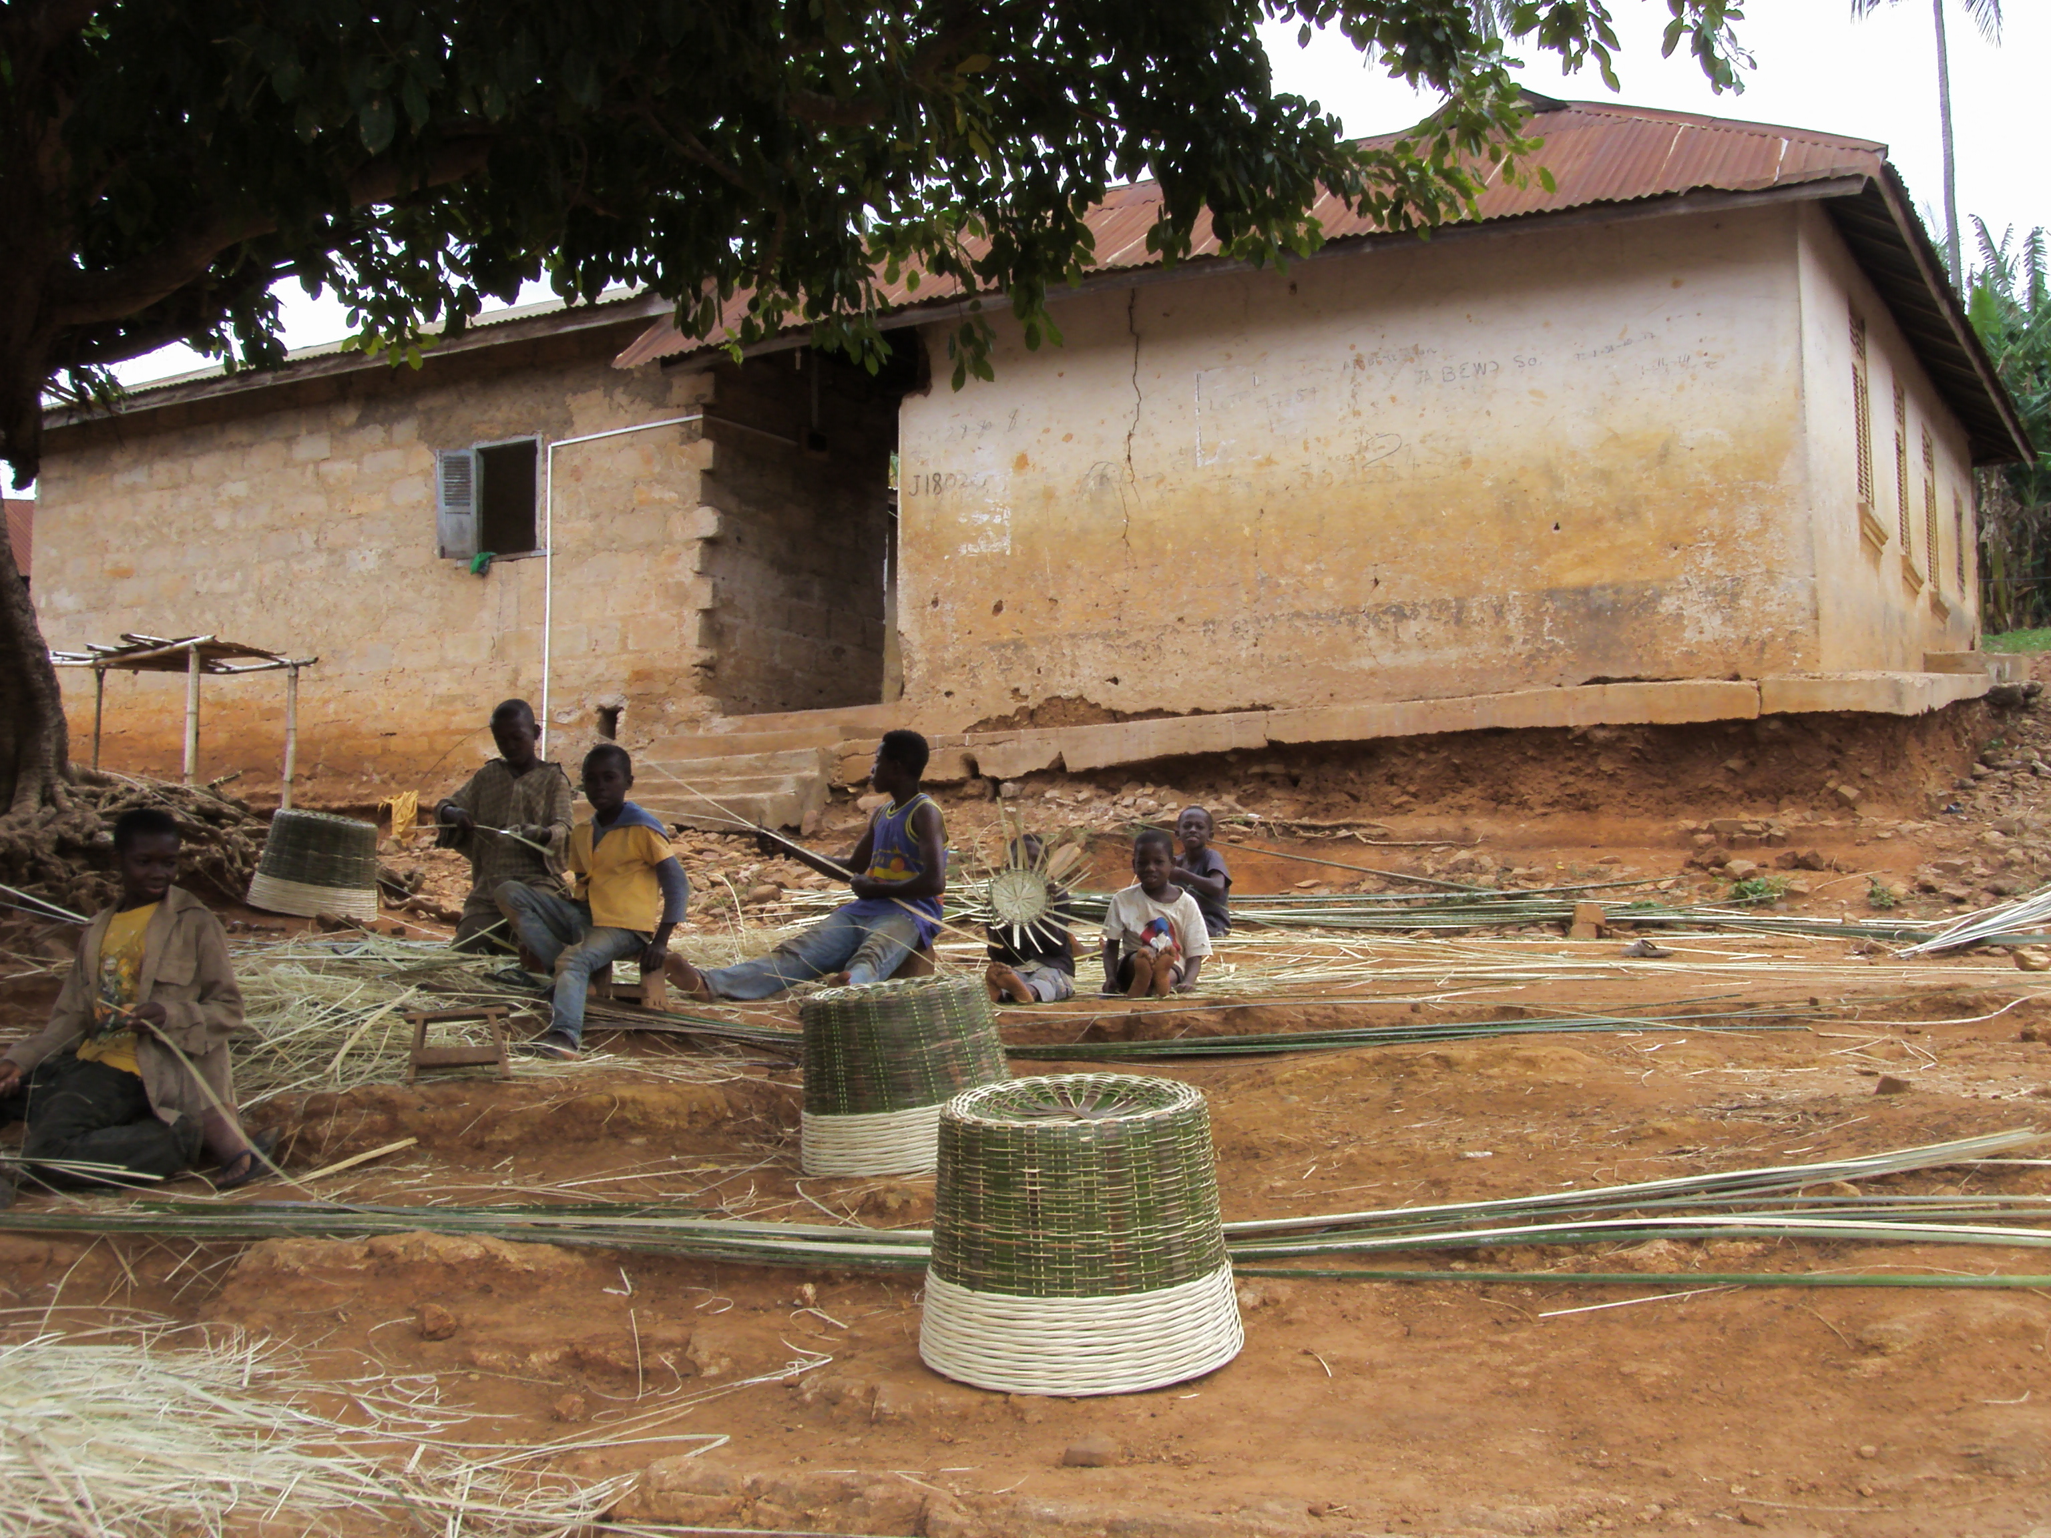

This note is based on visits to the village and interviews with the community on 17 April 2012.

Jansa is a village of some 250 people, divided into 37 households. It is situated about 4km south of the District Centre at Nsuta in Sekyere Central (local authority) District.

The people of Jansa are subsistence farmers. Their principal crops are cassava, corn, yam, cocoa and some vegetables like cabbage, carrots and tomatoes. They are also well known for their skill at weaving, and the picture above shows children weaving baskets.

Jansa has a committee of Chief and Elders which works alongside a Unit Committee (elected village committee). There is also a Water and Sanitation Committee, responsible for water points, sanitation and the general cleanliness of the village. Unfortunately it wasn't functioning at the time of our visit.

Water and Sanitation
There is one borehole in Jansa, and the people also draw water from the Sunfua and Supong streams, which are highly polluted.

There are two traditional pit latrines, which are in a bad condition. It is therefore likely that most people use the bush, with seepage adding to the general pollution in the streams. Two members of the community have constructed latrines for their households.

Health/ Schools
Nsuta Clinic is the nearest place for the people to obtain health care.

The village has a primary school, but children need to go elsewhere for further education.

There are Roman Catholic and Pentecostal churches.

The Future
The people told us that above all else they would like to have household latrines and income support such as agricultural training and loans, or microcredit (business training and small loans) for the women.

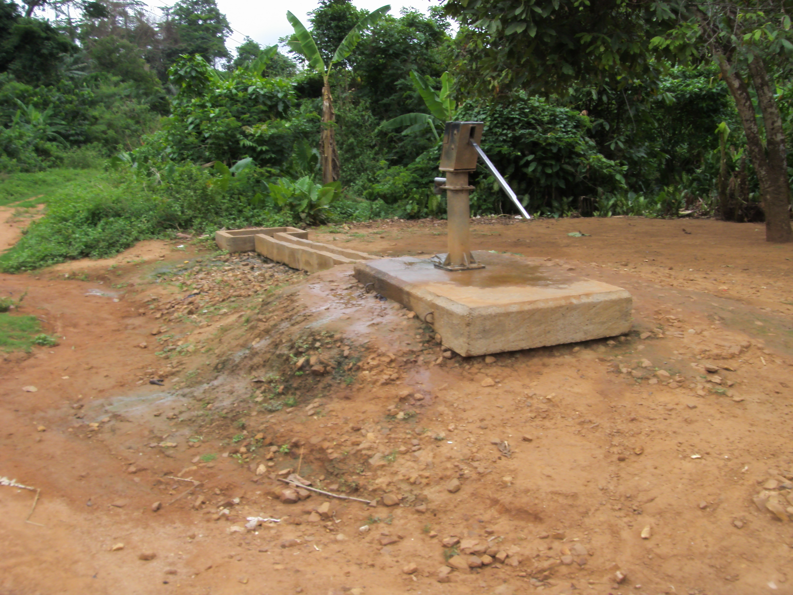

Borehole at Jansa

