

ATONSUAGYA, ASEMPANAYE and ISHATIA KUAKURO

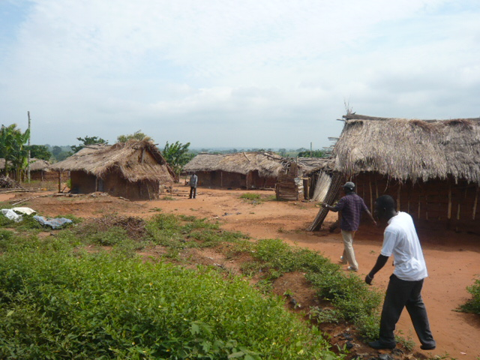

This note is based on a visit to Atonsuagya and interviews
with the Chief and community on 20 July, 2011

Chief: Nana Antwi Buasiako
Assemblyman: Raynold Atta Yaw
Elder: Nana Kwasi Oduro,

Atonsuagya is a community of some 3,000 people, situated just off the main road running north from Mampong to Ejura. Mampong is the local authority centre for Mampong Municipal Assembly, in which Antonsuagya is situated.

The village has two satellites villages situated three miles away, Asempanaye and Ishatia Kuakuro each with populations of about 1,000.

The villagers are subsistence farmers, producing maize, cocoa, cassava, plantain and vegetables. The women also sell soap made from cocoa husks. Cocoa is harvested and dried, after which the government collects it, paying the farmers in line with the price they have agreed with the buyers. We were told they might take 3,000 bags of 50 kilos each of dried cocoa from the village. The main diet was based on yam and cassava or plantain, fish and beans, and meat was eaten only for festivals.

Water, Sanitation and Health
The village use water from three boreholes and a highly-polluted stream. For sanitation,
there is one brick-built communal latrine in the Antonsuagya and two filthy, full, traditional communal latrines, one for men and one for women. There is no Water and Sanitation Committee so the Unit Committee manages the water and two rubbish tips. We were therefore not surprised to learn that they estimated infant mortality at three babies out of every ten – considerably above average – though they don’t make the connection to poor sanitation. We were told that no-one possessed a mosquito net.

We were told that the principal diseases were malaria, diarrhoea and measles. The Government provides vaccinations against measles, but most children had not been vaccinated. The community mainly uses Mampong Hospital when sick.

Schools
The village has a kindergarten/nursery of 300 children which meets in a church and urgently needs classrooms. There are another 550 children in the primary school, with eighty to a classroom. If children want to continue their education after primary school, their parents send them to Mampong because of the shortage of classroom space in the village.
The primary school consists of six classrooms, three of which were financed by the Ashanti King. The other three were built by the Millennium Development Authority, who informed the community they intended to build a school with no enquiries as to what was needed. The community accepted this, but moved the children around to make the most of the available accommodation. There is a Junior High School which meets, weather permitting.

Miscellaneous
There are seven religions in Antonsuagya - Seventh Day Adventists, Catholics, Christ Healing Church, Methodists, Pentecostal, Islam, Grace Church. There are no witchdoctors.
The village told us its principal needs were for a communal latrine (they had never seen household latrines), microcredit, better water, and a Junior High School.
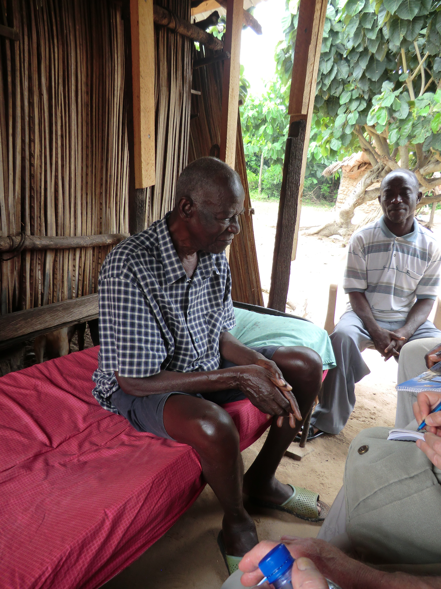

History – as told by Nana Kwasi Oduro (pictured), who is blind. Led by Kwasi Moshi from Adigdwan, the community left Mampong and embarked on a search for fertile land. The name of the town was Atonsi (river) Adgy, which means 'on the other side of the river' – since they'd had to cross the river to reach it. They have lived here for over 150 years. They know this because people often use the year of Ghana’s first earthquake, 1850, as a starting point.
They have never gone to war. They are a peaceful community. Atonsuagya includes people from northern Ghana, who have integrated well. They are typically much poorer, and in the past were taken as slaves by the Ashantis. Today, some of them are village elders, and one of their leaders has been chosen to work with the chief in his palace.

