

BRENGO

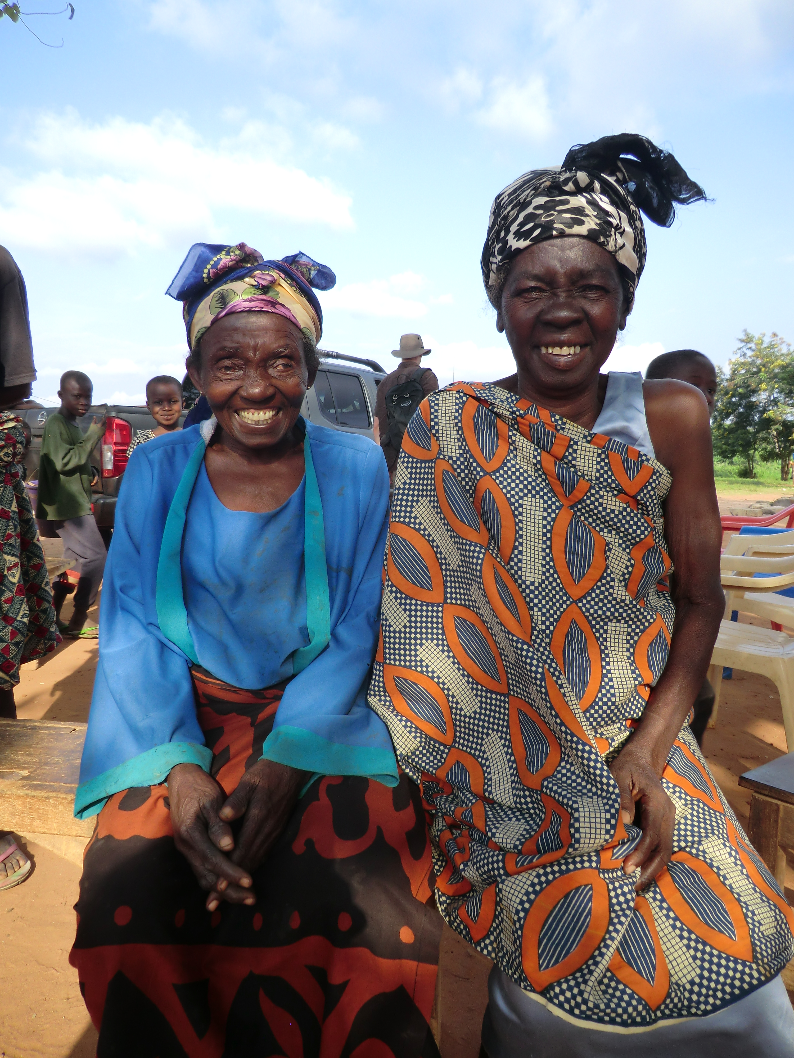

This note is based on interviews with the Chief
and community on 25 July, 2011

Nana Yaw Owusu Amoako – Chief
Ohemaa Afua Ako – Queen Mother

Brengo is a community of 2,000-2,300 people, divided into some 85 households. It is situated some 3km off the road running north from Mampong to Ejura. Mampong is the local authority centre for Mampong Municipal Assembly, in which Brengo is situated and is also Brengo's nearest market town.

The people of Brengo are subsistence farmers. Their principal crops are yam, corn, oranges, cassava, avocado, vegetables, spinach, egg plant, tomatoes, ground nuts, mango, pineapple and papaya. They rarely eat meat, but buy fish from Mampong Market. They told us they had a communal orange plantation and have also bought a corn mill for communal use.
Water and Sanitation
Water is provided by one borehole and a stream. We have added Brengo the the list of villages to be visited by the drilling rig, for which we will look separately for finance.

We were told there were two traditional pit latrines, one for men and one for women, but on inspection we found these were no more than areas of land, surrounded by bushes and used as latrines. There were two household latrines.

The Water and Sanitation Committee consisted of three men and two women. There was also a Unit Committee of six men and three women.

Health
People who were sick could travel by taxi to Mampong Hospital, which wasn't far, or they could take the long walk through the bush to Kofiase Clinic. The community told us that their main sicknesses were malaria and diarrhoea. They could not estimate the rate of infant mortality, but thought it was better than most places because of the accessibility of Mampong Maternity Hospital. The old people also said they were suffering from waist and chest pains, some of which may have been due to carrying heavy loads on their heads.

Schools and Churches
There is no kindergarten, but the primary school has 230 children, with ten teachers. There are two communal latrines for boys and girls and a urinal for boys. Brengo’s churches include Presbyterians and several Pentecostal and apostolic churches. There are no witchdoctors.

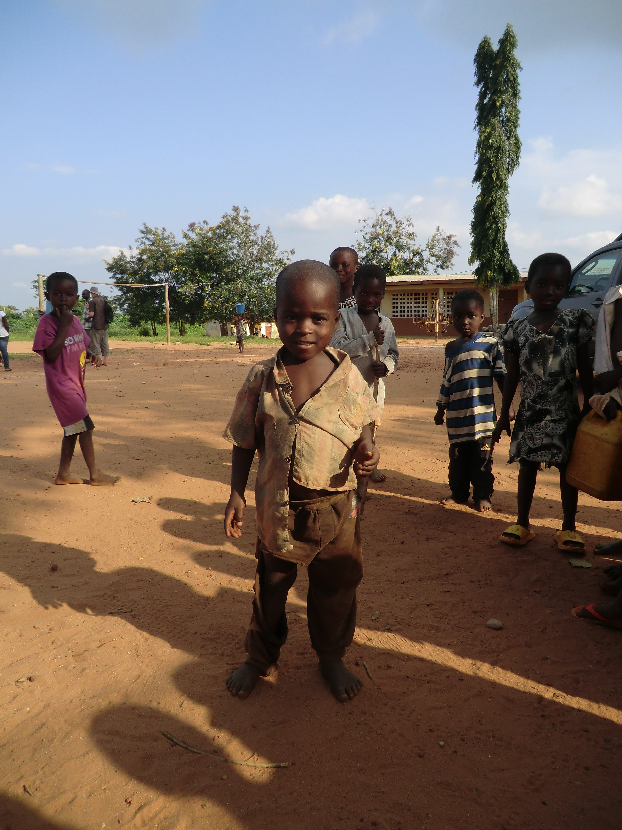
History
The people originated from a village called Honoo.
They left it during colonial times because of
persistent wars. They were led by Nana
Pentemprah. Eventually they settled at Abuontem,
which is situated on a main road, and they feared
their children would get hurt by cars. So they
decided to move into the interior, and finally settled
here. They chose this place because the land was
fertile.

Later, another group came and asked if they could
settle at Brengo. They were asked to settle further
on the hills, but the chief asked that they should
always come here so that they could play the
drums together. This brought about the name
Brengo, which means “come and let's play the
drums together.”

